



Selection, reapplication and firm outcomes in Innovate UK funding
IRC Report No: 076

EXAMINING THE INNOVATION FUNDING LIFECYCLE
Federico Bignone
Warwick Business School
Ammon Salter
Warwick Business School
Stefano Baruffaldi
Politecnico di Milano

Name Person (EXCL PREFIX)
Institution
Name Person (EXCL PREFIX)
Institution
Name Person (EXCL PREFIX)
Institution

Name Person (EXCL PREFIX)
Institution
Name Person (EXCL PREFIX)
Institution
Name Person (EXCL PREFIX)
Institution

Name Person (EXCL PREFIX)
Institution
Name Person (EXCL PREFIX)
Institution
Name Person (EXCL PREFIX)
Institution

REPORT PREPARED BY

REPORT PREPARED BY

REPORT PREPARED BY

REPORT PREPARED BY

Authors
The core members of the research team for this project were as follows:
- Dr Federico Bignone – Warwick Business School
- Professor Ammon Salter (PI) – Warwick Business School
- Professor Stefano Baruffaldi – Politecnico di Milano
This document relates to IRC Project FFCoE002: Examining the Innovation Lifecycle
Acknowledgements
This work was supported by Economic and Social Research Council (ESRC) grant ES/X010759/1 to the Innovation and Research Caucus (IRC).
We are very grateful to the project sponsors at UK Research & Innovation (UKRI) for their input into this research. The interpretations and opinions within this report are those of the authors and may not reflect the policy positions of UKRI or its constituent councils. We would also like to acknowledge and appreciate the efforts of the IRC Project Administration Team for their support in preparing this report.
About the Innovation and Research Caucus
The Innovation and Research Caucus supports the use of robust evidence and insights in UKRI’s strategies and investments, as well as undertaking a co-produced programme of research. Our members are leading academics from across the social sciences, other disciplines and sectors, who are engaged in different aspects of innovation and research systems. We connect academic experts, UKRI, IUK and the ESRC, by providing research insights to inform policy and practice. Professor Tim Vorley and Professor Stephen Roper are Co-Directors. The IRC is funded by UKRI via the ESRC and IUK, grant number ES/X010759/1. The support of the funders is acknowledged. The views expressed in this piece are those of the authors and do not necessarily represent those of the funders.
Contact
You are also welcome to email us if you have any questions about this report or the work of the IRC generally: info@ircaucus.ac.uk

Cite as: Bignone, F., Salter, A., and Baruffaldi, S. (2026). Examining the innovation funding lifecycle: Selection, reapplication and firm outcomes in Innovate UK funding. Oxford, UK: Innovation and Research Caucus.

CONTENTS
EXECUTIVE SUMMARY 4
1. Introduction 7
2. Innovate UK funding framework and data 9
3. Empirical strategy and interpretation 14
4. Part I: Selection into Innovate UK application 17
5. Part II: Reapplication after rejection 21
6. Part III: Effects of Innovate UK funding 29
7. Discussion and policy implications 38
REFERENCES 42

EXECUTIVE SUMMARY
Background
This report explores the role that Innovate UK (IUK) funding has had in the development and growth of UK new ventures, especially AI startups. It focuses on three main areas, trying to capture the lifecycle of innovation funding:
- Selection into application: why certain AI new ventures apply for IUK funding and others do not.
- Reapplication after rejection: whether rejection discourages or encourages reapplication, and how applying for IUK funding affects future engagement with the funding system.
- Effects of funding: the impact of IUK funding on non-traditional measures of firm outcomes, including scientific outputs, use of open-source code, R&D-related hiring, and the likelihood of securing additional venture funding.
Data and empirical approach
The analysis combines data from IUK applications, including both funded and unfunded applicants, firms connected to IUK communication and promotion channels, company funding information, and measures of engagement with science, including scientific publications, collaborations, and hiring of employees in research and development (R&D). The analysis focuses on startups, as they face significant financial constraints. To address our questions, we pair data from IUK with AIVRO, a rich database of UK AI startups. The first part of the analysis is descriptive, while the second and third parts rely on a regression discontinuity design (RDD) to provide causal estimates.
Main findings
With respect to the decision to apply for funding and focusing on AI startups, we find that entry into the funding system is highly selective, as startups that apply are not representative of the wider population. Among the universe of all AI startups, application to IUK is associated with location in particular regions, prior venture funding, university spinout status, and prior engagement with IUK communications channels. Thus, we show that IUK attracts a selected population of firms, as those AI startups with certain locations, origins, and prior funding history have a ‘head start’ over others in the decision to apply. We believe these differences may be due to the differences in knowledge about IUK arising from relationships with key stakeholders, such as universities.
Turning to the experience of applicants and zooming out to all companies, we find that companies that narrowly miss funding do not leave the IUK system in the short run. Instead, they are more likely to reapply quickly, and they also have a higher probability of winning subsequent funding over the same period. Zooming in on startups, we find that rejected startups are more likely to reapply in the short run than those that win funding. However, the pattern reverses in the long run, as funded startups are more likely to apply again over longer horizons. Being in an IUK ‘Blue Zone’ — being told that the application was fundable but not funded because of a lack of resources — does not appear to encourage firms to apply again. These results suggest that IUK funding decisions do not discourage most companies from reapplying, as they eventually ‘bounce back’ from rejection to reapply at similar rates to funded firms. However, we do find a potential discouragement effect on startups.
We explore the effect of funding on startups, focusing on their ability to attract additional venture funding. We find that IUK funding plays a causal role in attracting further venture funding, indicating that IUK funding ‘crowds in’. Using conservative estimates, we find that £1 of IUK funding is associated with approximately £1.68 in additional venture funding, with a 90% confidence interval from £0.44 to £3.08. However, the effects of IUK funding for other science and technology related outcomes are more ambiguous. Companies that are already actively publishing and collaborating are more likely to publish more after IUK funding. However, the opposite applies to startups, which appear to publish and collaborate less after IUK funding. The effect of IUK funding on hiring is mixed, as our exploratory analysis finds no consistent evidence that funding increases R&D hiring in subsequent years. In addition, we find no clear effect on companies’ open-source software activity on GitHub due to IUK funding. We also find that winning IUK funding does not alter companies’ chances of survival.
Interpretation and implications
We see several implications of our research for IUK and innovation policy in general.
Widening the funnel, not just the funding — The results suggest that companies clearly self-select into IUK competitions, and that such choices may be influenced by where these companies are located, how they were created, and who funds them. This suggests that differences in engagement in IUK competitions are partly driven by these AI startups’ stakeholders and environment as well as internal choices. As such, IUK needs to increase its efforts to onboard startups, and broaden its engagement to those startups that lack these relationships.
Established firms shrug off rejection; startups carry the scar — Companies that apply to IUK and are rejected do not appear to be discouraged from reapplying for funding in the long term. This suggests that rejection and high failure rates in competitions are not having a deterrence effect on most companies. However, our results show that startups that are rejected are likely to feel the ‘sting of failure’ for many years afterwards. This indicates that IUK needs to find ways to engage rejected startups to consider reapplication after failure, so they are not deterred from trying again. Extra support and attention should be given to raise awareness of the potential for reapplication and build these companies’ ability to bounce back.
Grants attract capital, not additional research activity — We find causal evidence that IUK funding stimulates additional external venture financing, as startups receiving a grant are more likely to obtain funding and to raise larger amounts than those rejected. These effects are large and consistent, and they mirror the results of other reports for other R&D grants programmes and R&D tax credits. However, we find little evidence that IUK funding increases publications, software contributions, R&D hiring, or even firm survival. This suggests that the funding may help with obtaining additional resources for exploitation rather than exploration. Further work will be required to understand other more downstream, near market effects of IUK funding.

Introduction

Policy context
IUK funding is a major policy instrument for supporting business innovation in the UK. Through competitive grants and related programmes, IUK supports firms at different stages of development, from early feasibility and experimental development to larger industrial research projects. While the funding is usually intended for the project level, it may generate further benefits beyond the focal projects, such as helping firms develop capabilities, attracting follow-on finance, or expanding their workforce.
This report examines the role of IUK funding in the development of UK new ventures, with particular attention to AI startups. The UK has a large and growing population of AI new ventures, including high-profile firms such as Graphcore, important AI divisions of leading firms such as Google DeepMind, and new entrants developing specialised AI applications. Many of these firms are closely connected to the UK science base and operate in a sector that has received substantial public and private investment (Perspective Economics, 2023).
IUK has made significant and ongoing investments in AI as part of the wider UK Government’s AI strategy. Between 2005 and 2020, IUK committed at least £323 million to 757 projects supporting firms developing AI-based technologies through various programmes (Ipsos MORI, 2021). Existing evidence has examined the impact of IUK support and the effects of R&D grants on firm outcomes more generally (Dimos & Vorley, 2023; Mulligan et al., 2026; Vanino et al., 2019; Wilson et al., 2026). However, less is known about how firms, especially startups, enter the IUK funding system, how they respond to application outcomes, and how funding affects subsequent firm development.
This project was co-developed with IUK and emerged from overlapping research and policy interests. On one side, the ESRC project, Profiting from Science: The Development and Valuation of Artificial Intelligence New Ventures and Engagement with the Science Base, aims to track the scientific engagement of UK AI startups and examine whether such engagement influences the valuation attributed to them by investors. On the other side, IUK was interested in understanding which firms it attracts, whether they remain engaged with the funding system over time, and whether IUK funding generates benefits beyond conventional productivity measures.
To address these questions, this report combines IUK internal records, including all funded and rejected applications between 2017 and 2024, with firm-level and scientific engagement data from Beauhurst, Scopus, GitHub, and Revelio Labs.

Research questions
To understand the public innovation funding system, it is important to examine the different phases that compose it. Most existing evidence starts from the funding decision and asks what happens to firms that receive grants relative to those that do not. This is an important question, but it misses two important stages: which firms enter the applicant pool in the first place, and how firms respond when they are not funded.
This report examines IUK funding as a three-part lifecycle. The three parts of the analysis correspond to three stages of that lifecycle, each of which is necessary for understanding how public innovation funding works in practice.
- Who applies? Public funding can only affect firms that enter the applicant pool, and entry is not random. If applicants are a selective subset of the firm population — concentrated geographically, more visible, or more likely to have prior finance — then the reach of the funding system depends partly on what happens before the application deadline. Understanding selection into application is therefore a precondition for interpreting everything that follows.
- What happens after rejection? Most IUK applications are not funded. How firms respond to rejection determines whether the funding system retains or loses potentially strong applicants. Rejection could discourage firms from applying again, particularly where application costs are high or firms are financially constrained. But a near miss might also encourage rapid reapplication if firms believe their project was close to being fundable.
- What are the effects of funding? Public funding may help firms ‘crowd in’ further private investment, as well as affecting other dimensions of firm activity, including survival, publications, open-source activity and R&D hiring.

Report overview
Section 2 describes the IUK funding process and the data used in the analysis. Section 3 explains the empirical strategy and the interpretation of the regression discontinuity estimates. Sections 4, 5 and 6 present the empirical results for selection into application, reapplication after rejection, and the effects of funding. Section 7 discusses the policy implications of the findings, reflects on limitations, and draws conclusions.

Innovate UK funding framework and data

The Innovate UK funding process
IUK is the UK’s main public agency for supporting business-led innovation. Its funding is allocated mainly through competitive grant programmes, which support firms and project consortia working on activities such as feasibility studies, industrial research and experimental development. The competitions examined in this report represent a selective funding system: firms apply to specific calls, applications are assessed and ranked, and only a subset receive support.
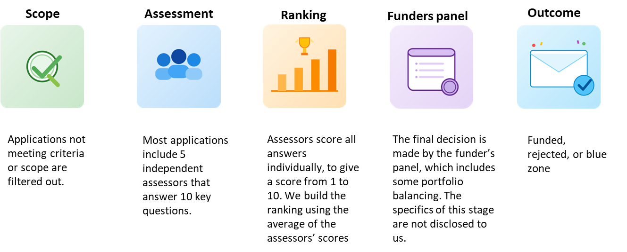
Figure 1 summarises the main stages of the funding process: from the scope and eligibility screening to the outcome notification. This process is important for the analysis because the data observe several stages of the application process, including assessment scores, funding outcomes and application histories, but do not observe all information used in the final panel decision.

Figure 1: Innovate UK funding framework

Scope, assessment and funding decisions
Only applications that meet the eligibility criteria and scope of the competition are sent for assessment. Each application has a lead applicant, which is the main partner responsible for ensuring that all project details are completed. Some competitions also involve partner organisations, referred to as collaborators, with eligibility rules specifying which types of organisations may participate. Each partner organisation is responsible for completing its own project costs and financial information.
Most IUK assessors are UK-based, and the assessor pool includes experts from both business and academia. Approximately one month before the competition deadline, the Innovation Lead invites assessors to participate. Available assessors are matched to applications based on the subject area of the proposal and their expertise. The allocation process remains partly manual and relies on the Innovation Lead’s interpretation of assessor expertise, although the process has evolved over time.
During the period of our study, the assessment system was relatively stable. Once received, applications are assessed by up to five independent assessors using largely common scoring criteria. Assessors score each answer separately, which means that a typical application receives around 50 question-level scores. Scores range from 1 to 10 and are accompanied by score anchors. Assessors also provide a final funding recommendation, but the analysis observes the numerical scores rather than the final Yes/No recommendations.
The final funding decision is made by the IUK funders panel. Successful applications must satisfy quality criteria, but final decisions may also reflect budget constraints and portfolio balancing. The analysis does not observe the panel deliberations or the full decision rules used at this stage. After assessment, lead applicants are informed of the funding decision by email. Written feedback is typically provided for each scored question, but this report does not observe the feedback text or whether applications subsequently fail due diligence. This information was not included in the materials supplied to the research team.

Data sources and sample construction
To address our research questions, we assembled data from several heterogeneous sources. We did not use data on R&D spend and patenting, as we are primarily focused on AI startups. Since these firms tend to be small and new, their R&D spend is not easy to measure from public records. Moreover, patenting is relatively uncommon among AI startups, with less than 6% holding a patent.
- Applications data: IUK applications. We use IUK internal application records covering both funded and rejected applications. These data include information on competitions, application outcomes, assessment scores, funding decisions, requested funding, project duration, applicants, and collaborators. These applications cover Industrial Research, Feasibility Studies, Experimental Development and other programmes. Knowledge Transfer Partnerships (KTP) are excluded because funding rates for these programmes are substantially higher as the criteria for entry require multiple year in-cash commitments by companies. As such, the funding process is less comparable to the competitive grant settings examined here. The data cover the period from 2017, when IUK shifted all applications to a new online portal, to 2024, the last year for which data were available for the study.
- IUK promotion data: This captures firms connected to Innovate UK mailing lists, communications channels or funding alerts. The data identify which firms signed up to which alerts, but not the exact timing of the sign-ups. The research team was given access to all firms that may have registered for AI-related competitions.
- Company information: We use Beauhurst to capture firm-level characteristics, including founding dates, location, sector classifications, funding events, investors, and company status.
- Scientific publications and collaborations: We use Elsevier’s Scopus database to identify scientific publications associated with applicant firms and collaborations with universities or other research organisations.
- Open-source code: GitHub is the main online platform used by developers, firms and researchers to host and share software and code. We use GitHub to capture firms’ open-source software activity, collecting all repositories associated with applicant firms.
- Employee-employer data: We use Revelio Labs to construct longitudinal measures of firm-level employment and workforce composition, including indicators of employees working in research and development positions. Revelio Labs data include information from LinkedIn and other social media sites about employees at various UK companies. Since LinkedIn has almost 50 million users in the UK, it is reasonably comprehensive.
The report uses three related analytical samples, summarised in Table 1. Our analysis shifts between these levels, although our primary focus is on startups, especially AI startups. We need to include all companies in our analysis to ensure that our results are not a product of the specific features of the startup sample. In addition, the RDD approach requires data on applications across the full score distribution within each competition to identify the funding threshold and determine the bandwidth used in the analysis. Our focus on firm outcomes is directed towards outcomes most related to startups. We do not attempt to capture firm growth by sales or employment, as these figures may be unreliable for small firms from public sources and many of these firms have modest levels of sales, especially in AI.

Table 1: Samples used in the report
Sample | Definition | Main use in the report
All Innovate UK applicants | Innovate UK applications from 2017 to 2024 matched to firm-level data | Broadest sample; used to study reapplication behaviour and to provide full-sample estimates around the funding threshold
Startups | Firms incorporated after 2017 | Tighter sample used to observe application behaviour from incorporation onwards and to examine whether reapplication behaviour and funding effects differ for younger firms
AI Startups | UK AI startups founded since 2017, identified using AI-related Beauhurst categories and manual verification | Main sample for selection into application; subgroup in the reapplication and funding-effect analyses
Note: The samples overlap. Some AI firms are startups, and some startups are included in the broader Innovate UK applicant sample.

AI startups are defined using a broad classification based on automated text screening of websites and firm descriptions followed by manual verification. The relevant Beauhurst categories include Artificial Intelligence, Generative AI, Intelligent Systems, Machine Learning, Natural Language Processing, Predictive Analytics and Robotic Process Automation. This classification builds on data work developed for the AI Ventures Research Observatory (AIVRO), a dataset used to identify and track UK AI new ventures.
Table 2 provides a high-level overview of the AI firm population used in the selection analysis. The data identify 12,225 UK AI startups. Of these, 1,792 applied to Innovate UK, 615 received funding, and 397 are linked to Innovate UK communication or promotion channels.

Table 2: AI firm population and Innovate UK application status
Group | Number
All UK AI startups | 12,225
IUK AI applicants | 1,792
Funded firms | 615
Promotion-linked firms | 397
Note: The table summarises the AI firm population used in the selection analysis.

For the reapplication and funding-effect analyses, the report uses the broader Innovate UK application data matched to Beauhurst and related sources. Table 3 shows the main application sample. Across 808 competitions, the data include 78,564 applications. Most applications are rejected, while 18% are funded and 10% fall into the Blue Zone category.

Table 3: Innovate UK application sample, 2017-2024
 | Rejected | Blue Zone | Funded | Total
Applications | 56,544 | 7,538 | 14,482 | 78,564
Percentage | 72 | 10 | 18 | 100
Competitions | 719 | 114 | 798 | 808
Companies | 33,972 | 5,998 | 8,893 | 38,565
Funding sought (£m) | 12,420.17 | 1,629.86 | 4,135.20 | 18,185.23
Note: Counts are based on Innovate UK applications matched to firm-level data. Blue Zone refers to applications assessed as fundable but not funded because of budget constraints or competition-specific decisions.

Table 3 also highlights the competitiveness of the funding environment. Rejection is the most common outcome, making it even more important to understand firms’ post-rejection behaviour.

Empirical strategy and interpretation

Empirical approaches
The report uses different empirical approaches for different stages of the funding lifecycle. The selection analysis in Part I is descriptive and correlational. It compares AI startups that apply to IUK funding with AI startups that do not apply, and it studies whether startups connected to IUK communication channels are more likely to apply. This evidence is useful for understanding who enters the applicant pool, but it does not identify causal effects.
Parts II and III use a fuzzy Regression Discontinuity Design (RDD) (Calonico et al., 2025; Cattaneo & Titiunik, 2022). This design compares applications just above and just below competition-specific funding thresholds. These applications are close in assessment score and therefore similar in assessed quality, but they differ sharply in the probability of receiving funding. This provides a more credible basis for causal interpretation, but only for marginal applications close to the threshold.

Running variable and score centring
For each competition, applications are ranked using their assessment scores. We centre the running variable using the midpoint between the highest losing score and the next higher winning score. For example, if the highest losing score is 70 and the next higher score is 72, the threshold is set midway between them, so that 70 corresponds to -1 and 72 corresponds to +1.
This centring approach keeps the estimated discontinuity close to the effective funding threshold while allowing competitions with different score distributions and thresholds to be pooled. It is a practical compromise. On the one hand, it avoids placing the threshold too far from the observed transition between rejection and funding. On the other hand, because all scores are centred around a common threshold, it does not estimate a separate threshold for each competition. Importantly, the treatment effect is still estimated within competitions. The model therefore does not assume that all competitions are identical, or that all applications belong to a single common scoring process.
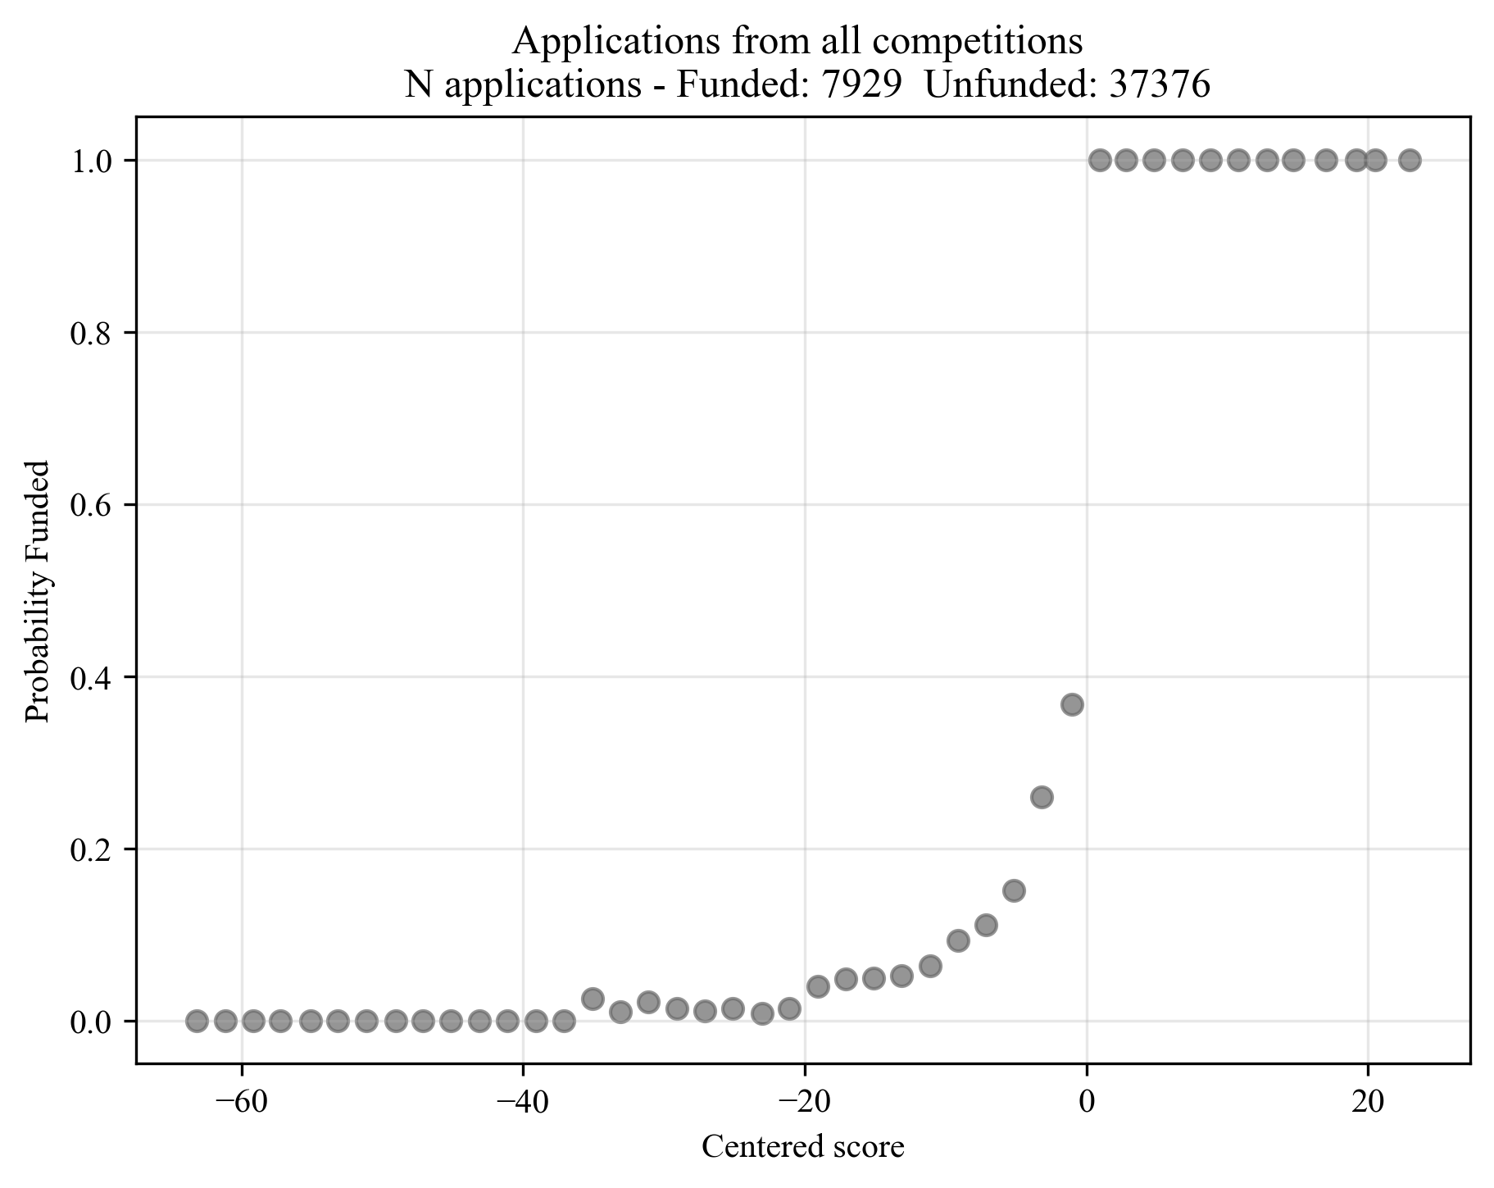
Figure 2 shows the relationship between the centred assessment score and the probability of receiving funding. The sharp increase in funding probability at the threshold is the first stage of the fuzzy RDD.
Bandwidth with firms used for RDD
Funding threshold

Figure 2: Discontinuity in the probability of receiving Innovate UK funding
At the cutoff, the probability of receiving funding increases by around 60 percentage points. This first-stage relationship is large enough to support the fuzzy RDD design. The estimate is not a comparison between all funded and all rejected firms. It is a local comparison between applications close to the funding threshold (the ones in the yellow area in Figure 2), where small differences in score are associated with a substantial difference in the probability of funding.

Outcomes, controls and validity checks
For the reapplication analysis, outcomes are constructed over 12, 18, 24 and 36 months following the competition submission. Reapplications during the first three months after submission are excluded to avoid capturing mechanical or administrative resubmissions and to allow time for funding decisions to be communicated.
Because the data are right-censored, we truncate the sample for each outcome window. Applications are included in a reapplication analysis only if they can be observed for the full 12, 18, 24 or 36 months after submission. For example, applications submitted too close to the end of the observation period are excluded from the longer windows, so that firms are not mechanically classified as not reapplying simply because we do not observe them for enough time.
In all the results figures, the red dot shows the local rejected-firm baseline, while the green dot shows this baseline plus the RDD estimated coefficient. The vertical distance between the two dots thus corresponds to the RDD coefficient.
For the funding-effect analysis, outcomes include venture funding, dissolution, publications, collaborations, open-source activity and R&D hiring over comparable follow-up windows. Venture funding includes private investment, such as venture capital and angel investment. Dissolution refers to cessation of activity in Companies House and does not include acquisitions or other successful exits.
The RDD specifications include project characteristics, prior application history and firm characteristics as covariates. Project characteristics include duration, funding sought, non-business co-applicants, application delay and research category. Prior application history includes previous wins, rejections and Blue Zone outcomes. Firm characteristics include size and location indicators. Standard errors are clustered at the competition level, and specifications include competition fixed effects.
The design requires applications just above and below the threshold to be comparable in predetermined characteristics. The analysis tests this by examining whether covariates are smooth at the discontinuity. The covariate checks show no systematic discontinuities at the threshold, with only 2 of 13 differences marginally significant at the 10% level: cumulative number of previous wins and feasibility studies. Figure 3 reports 12 of these covariates for readability.
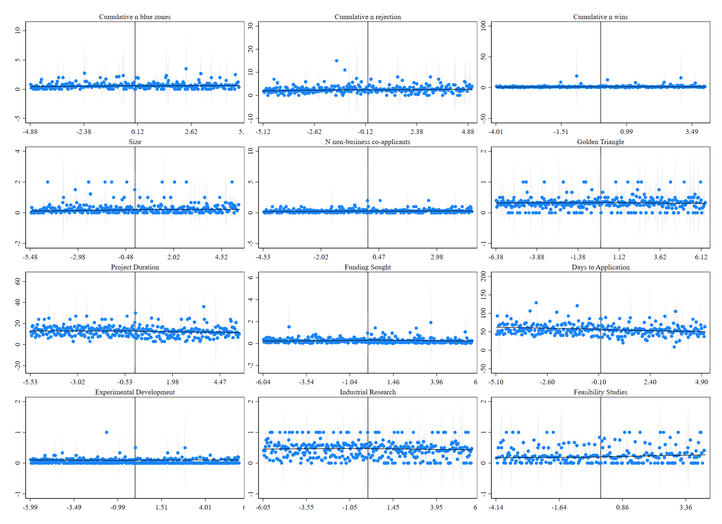

Figure 3: Smoothness of the covariates at the discontinuity

Part I: Selection into Innovate UK application

Why selection into application matters
The first stage of the funding lifecycle is entry into the applicant pool. Many startups may never formally apply for IUK funding. This may reflect lack of awareness, administrative burden, strategic non-fit, disclosure concerns, or higher opportunity costs for high-growth firms. Research on EU funding programmes found that high-growth, high-tech, patent-active and venture-capital-backed firms are more likely to apply (Mina et al., 2021). However, there is limited prior work on the UK, and it is likely that the IUK applicant pool is not representative of the broader firm population, as selection into R&D grant funding is high. Understanding who applies is thus important for interpreting any analysis of funded firms.
The evidence in this section is descriptive. Its goal is to document differences between applicants and non-applicants, and to show whether promotion, prior finance, or other firm characteristics are correlated with application.

Geographic concentration and repeated engagement
Application to IUK funding is geographically concentrated among AI startups. In absolute terms, the largest applicant counts are in Inner London – West, and Inner London – East, followed by East Anglia, Berkshire, Buckinghamshire and Oxfordshire, and Greater Manchester. This pattern partly reflects the geography of the AI firm population, especially the concentration of AI activity in London and the wider South East.
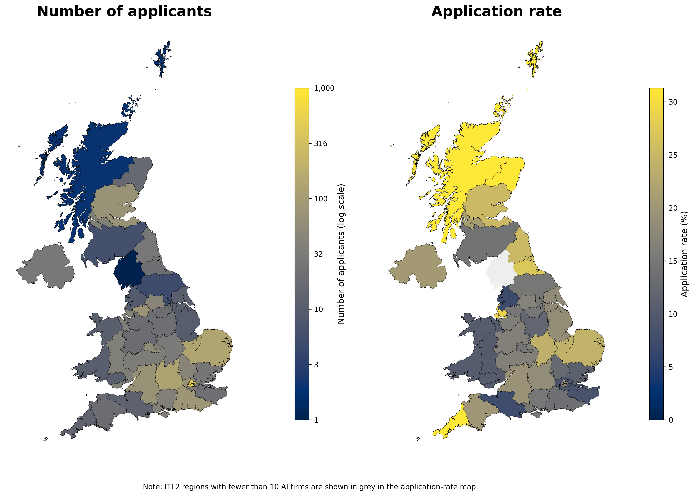
Application rates tell a somewhat different story. The highest application rates are found in several regions outside the largest London clusters, including Merseyside, North Eastern Scotland, Cornwall and Isles of Scilly, Leicestershire, Rutland and Northamptonshire, and Tees Valley and Durham. This distinction matters because high applicant counts and high application rates capture different aspects of geographic reach: some regions generate many applicants because they host many AI firms, while others have smaller AI populations but a relatively high share of firms applying to IUK funding (Figure 4).

Figure 4: Number of AI startup applicants and application rates by ITL2 regions

Repeated application is also common. Many AI startups submit multiple applications, and some startups receive funding more than once. AI startups are more likely to be repeat applicants and repeat winners than average firms. This means that the applicant pool includes firms with ongoing relationships with the IUK funding system, not only firms making a one-off attempt to secure funding.

Leading AI firms and observed valuations
Firms with observed valuations in Beauhurst data are much more likely to apply to IUK funding than firms without observed valuations. Table 4 reports application and funding rates by valuation category. Among AI firms with observed valuations, application rates are high across valuation tiers, ranging from 47.4% among firms valued between £100 million and £1 billion to 60.1% among firms valued below £100 million. Firms with no observed valuation are much less likely to apply, with an application rate of 8.3%. Around one-quarter of valued AI firms have received IUK funding, compared with only 2.4% of firms without observed valuations.
Table 4 suggests that IUK reaches a meaningful share of visible AI firms, including some firms with high observed valuations. However, the comparison with firms without observed valuations should be interpreted cautiously. Valuation data are incomplete and likely skewed towards firms that are more developed, better financed, or more successful.

Table 4: Innovate UK application among AI firms by observed valuation status
Group | Number of firms | Ever applied to Innovate UK (%) | Ever received Innovate UK funding (%)
AI firms valued £1bn+ | 4 | 50 | 50
AI firms valued £100m-£1bn | 19 | 47.4 | 21.1
AI firms valued below £100m | 1489 | 60.1 | 23.8
AI firms with no observed valuation | 10713 | 8.3 | 2.4
Note: Valuation data are incomplete and likely skewed towards more visible and successful firms. The table should therefore be interpreted as descriptive evidence for firms with observed valuations, not as representative evidence for all AI firms.

Firm characteristics and promotion-linked firms
Additional regression evidence reinforces these descriptive patterns. AI startups that apply to IUK differ systematically from those that do not. Applicants are more likely to be younger, to have previously received venture funding, and to be university spinouts. These patterns show that entry into the IUK applicant pool is related to prior external finance and links to the research base. The estimates remain descriptive, but they are important because they show that selection begins before the funding decision itself.
Regression specifications with firm fixed effects point in the same direction. Once the analysis compares changes within the same firm over time, most predictors weaken, suggesting that much of the variation in application is between firms rather than within firms. In these specifications, publication activity is the only clear negative predictor.
The data also identify AI startups connected to IUK mailing lists, communications or funding alerts. Promotion-linked AI startups are substantially more likely to apply for funding, and this relationship remains strong after adding firm characteristics and other controls. Promotion-linked applicants are also younger, more likely to have prior venture funding, more likely to be university spinouts, and more likely to be in Oxford or Cambridge.
This relationship is potentially important for policy because awareness and communication channels may shape the applicant pool. However, the timing limitation is central: the analysis does not observe exactly when firms joined the communication channels. As a result, the relationship cannot be interpreted as evidence that promotion caused application. AI startups already interested in IUK funding may be more likely to subscribe to communications, and those funded may be more likely to sign up to future communications.
In sum, the selection evidence shows that entry into the IUK applicant pool is uneven. Among AI startups, application is associated with geography, prior venture funding, university spinout status and engagement with IUK communication channels. These patterns are descriptive and should not be interpreted as causal evidence, but they do show that the applicant pool is already shaped before funding decisions are made.
This matters for interpreting the rest of the report. The effects estimated in Parts II and III apply to firms that have already entered the IUK system. They do not capture firms that may have been eligible or suitable for support but did not apply. The reach of IUK funding therefore depends partly on pre-application engagement: who becomes aware of the funding, who sees it as relevant, and who has the capacity to apply.
Having established that entry into the applicant pool is selective, Part II turns to the next stage of the lifecycle: what happens to firms after they receive a funding decision.

Part II: Reapplication after rejection

Why rejection may affect future application behaviour
A recurring concern in competitive grant systems is that rejection may discourage firms from applying again. This concern is particularly relevant where application costs are high, feedback is difficult to interpret, or firms are financially constrained. In the IUK setting, most applications are not funded, so post-rejection behaviour is a central feature of the funding lifecycle.
The expected effect of rejection is ambiguous. Rejection could discourage firms if applicants interpret it as a negative signal or if the cost of preparing another application is too high. However, a near miss could also encourage reapplication if firms believe the project was close to being fundable, if feedback helps them improve the proposal, or if they remain engaged with the same funding system.
Previous research has mainly examined encouragement and discouragement effects among academic researchers, with mixed findings. Bol et al. (2018) show that grant success can generate cumulative advantages, with early funding success increasing subsequent scientific performance and future success. Wang et al. (2019), by contrast, find that scientists who narrowly miss early-career funding can outperform narrow winners in the longer run, among those who remain active. These studies suggest that failure and success in competitive funding systems can shape future behaviour, but that the direction of the effect depends on the context.
The question is therefore whether similar dynamics apply to firms. Startups may respond differently from academic researchers because they face more acute financial constraints, shorter planning horizons, and stronger pressures to allocate managerial attention across competing activities. A rejection may discourage them from reapplying, but it may also lead them to revise the proposal and return quickly to the funding system.

Descriptive patterns in reapplication timing
Before turning to the regression discontinuity estimates, Figure 5 provides descriptive evidence on the timing of repeat applications among funded and rejected firms. The figure is useful because reapplication behaviour may differ across short and longer horizons, and a single cumulative outcome may conceal these dynamics.
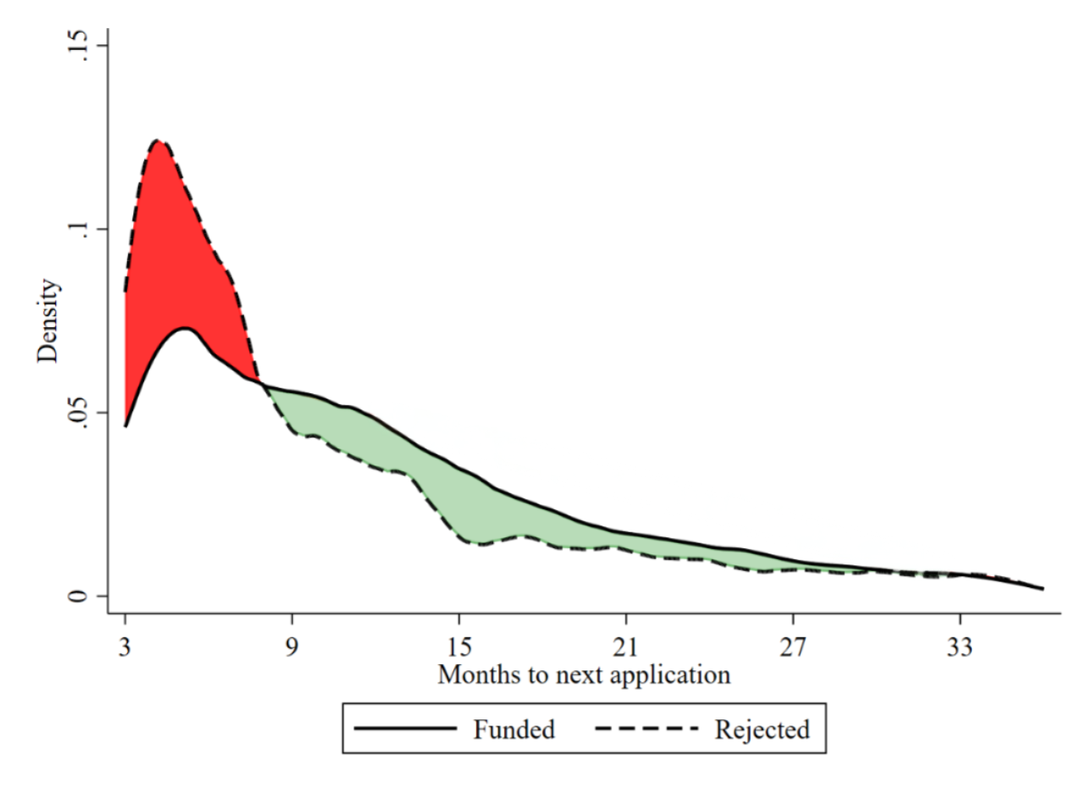

Figure 5: Time to next Innovate UK application among funded and rejected firms
Figure 5 shows that rejected firms return more quickly in the first months after the decision. The pattern then reverses, with funded firms becoming more likely to reapply at later horizons. The two distributions gradually converge over time. This descriptive pattern does not by itself show a causal effect of rejection, because funded and rejected firms may differ in many ways. However, it does help to motivate the RDD analysis by showing that reapplication behaviour is dynamic.

RDD estimates for reapplication
Figure 6 presents the main regression discontinuity estimates for reapplication in the full sample. Here we focus on all firms to start the analysis rather than the population of startups. The comparison is between firms just above and just below the estimated funding threshold within competitions. If near-miss rejection discouraged firms, we would expect firms just below the threshold to be less likely to reapply than firms just above it.
Firms just below the threshold are more likely to reapply within 12 months than firms just above it. Rejected firms have a 45.8% probability of applying again within 12 months, compared with 32.5% for funded firms. The effect becomes weaker at longer horizons and fades after 18 months. This result does not support the idea that near-miss rejection immediately pushes firms out of the IUK funding system. If anything, firms just below the funding threshold return more quickly in the short run. One possible interpretation is that near-miss firms remain engaged with IUK and revise or resubmit applications soon after rejection, while funded firms may initially focus on delivering the funded project. This mechanism is plausible, but it is not directly observed in the data.
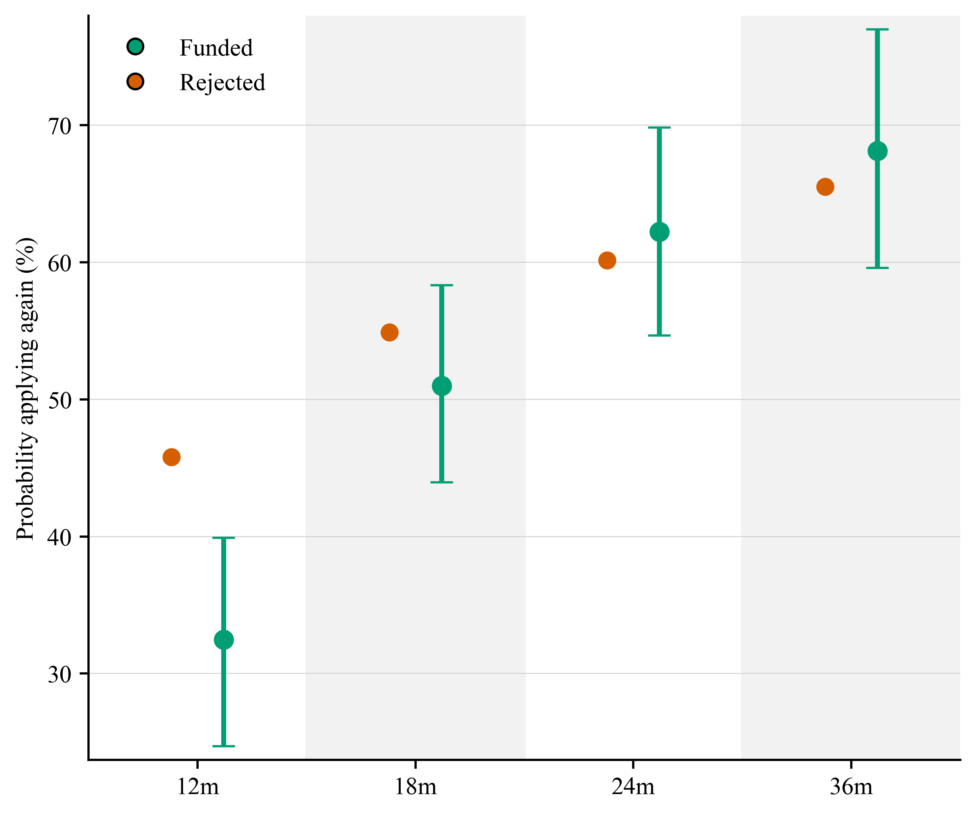

Figure 6: Probability of applying again within 12, 18, 24 and 36 months, full sample

RDD estimates for subsequent success
Reapplication is only one measure of continued engagement. A second question is whether firms that narrowly miss funding are more likely to win funding in a subsequent competition. Figure 7 reports the probability of winning at least once within 12, 18, 24 and 36 months.
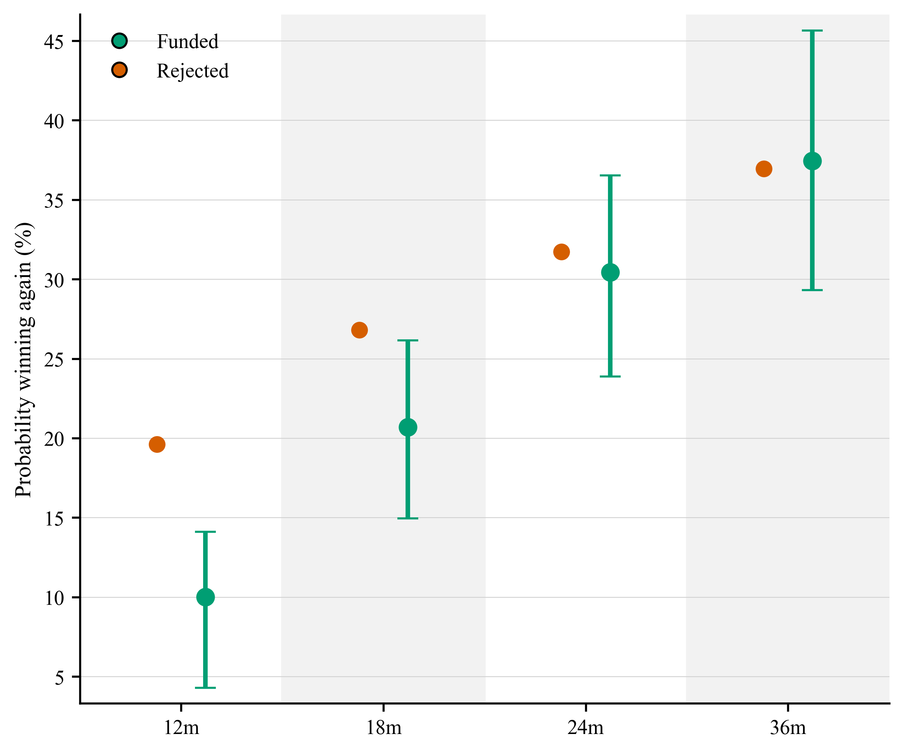
Figure 7 shows a similar short-run pattern. Firms that narrowly miss funding are more likely to win subsequent competitions in the short run. Within 12 months, the probability of winning a subsequent competition is 19.6% for rejected firms and 10.0% for funded firms. Within 18 months, the corresponding figures are 26.8% and 20.7%. This result may partly follow from the reapplication pattern: firms that apply more frequently have more opportunities to win. It may also be due to knowledge and experience gained through the application process that can be used in the next competition.

Figure 7: Probability of winning a subsequent competition within 12, 18, 24 and 36 months, full sample

Startup sample
The startup analysis uses a tighter sample of firms incorporated after 2017, allowing application behaviour to be observed since incorporation. This sample includes 31,064 observations across 296 competitions. Startups are important because they often face more severe resource constraints and may be more dependent on external project finance.
Figure 8 presents the reapplication estimates for this sample. The short-run pattern is similar to the full sample: startups that narrowly miss funding are more likely to apply again within 12 months. Within 12 months, 47.2% of rejected startups apply again, compared with 30.9% of funded startups. Over longer horizons, the pattern reverses. Within 24 months, 60.7% of rejected startups apply again compared with 73.0% of funded startups. Within 36 months, the figures are 65.1% and 80.3%.

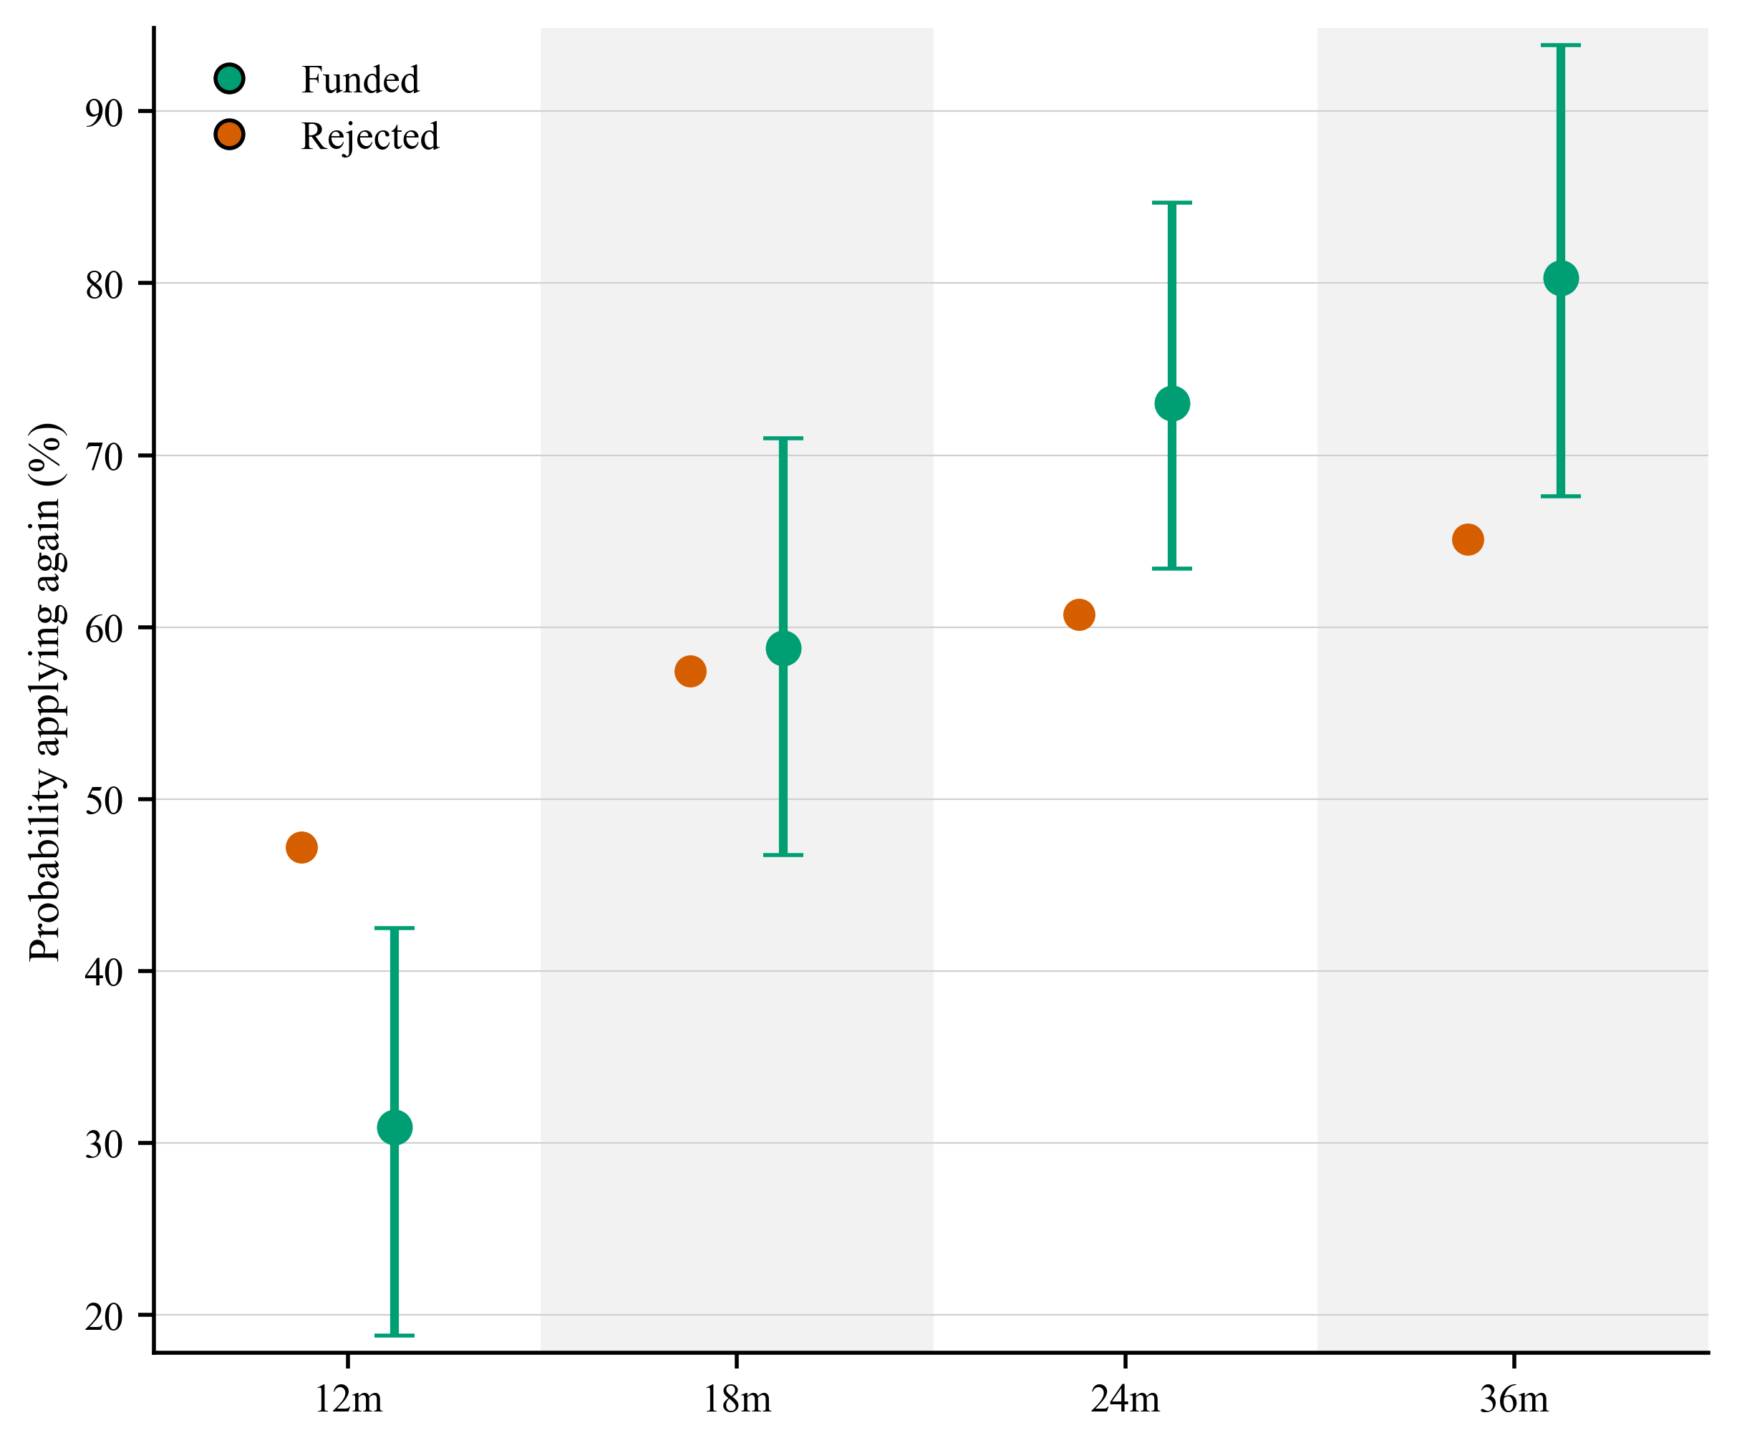
Figure 8: Probability of applying again within 12, 18, 24 and 36 months, startup sample
The startup results point to a two-phase pattern. Near-miss rejected startups are more likely to return quickly, but funded startups are more likely to re-enter the funding system over longer horizons. This suggests that the effect of a funding decision is not simply encouragement or discouragement. It changes the timing of future applications. Rejected startups may return quickly because they remain close to the funding threshold, while funded startups may initially focus on delivering the funded project before applying again.
Figure 9 examines whether this timing pattern also appears for subsequent competition success among startups. The pattern is consistent with the reapplication results. Funded startups are less likely to win a subsequent competition in the short run: within 12 months, 20.1% of rejected startups win subsequent competitions compared with 4.4% of funded startups. By 36 months, the pattern reverses, with 36.4% of rejected startups winning a subsequent competition compared with 49.5% of funded startups.
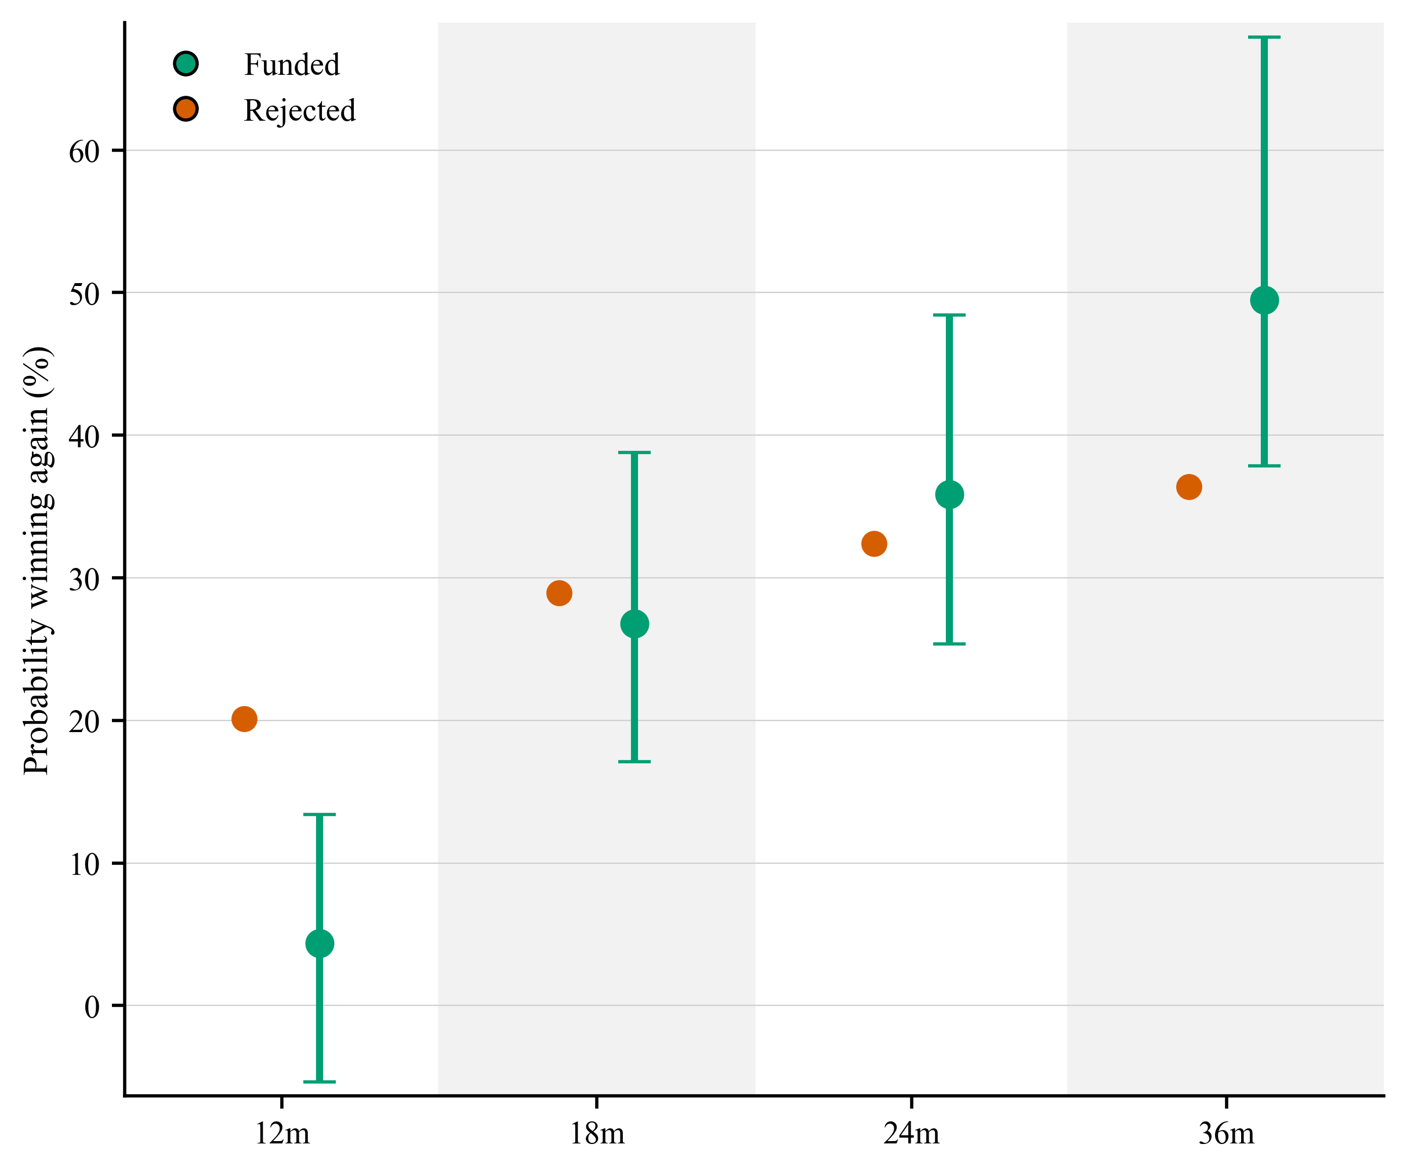

Figure 9: Probability of winning subsequent competitions within 12, 18, 24 and 36 months, startup sample

Heterogeneity and Blue Zones
The average reapplication results conceal some variation across competition and firm characteristics. The short-run reapplication effect is stronger in SMART competitions, which are highly competitive and open to all domains, and in highly contested competitions. It is also more visible among firms outside the Golden Triangle (London, Oxford and Cambridge). These patterns suggest that post-rejection behaviour is not uniform across the funding system. Firms may respond differently depending on the type of competition they enter, the intensity of competition, and their position within the wider innovation system.
The heterogeneity results do not suggest that AI firms respond in a fundamentally different way from non-AI firms in the short run. After 12 months, both AI and non-AI firms that narrowly miss funding are more likely to reapply, and the estimated effects are not statistically distinguishable from each other. After 18 months, the difference fades. At longer horizons, the AI estimates become less stable, reflecting smaller sub-samples and wider confidence intervals. The main implication is therefore not that AI firms behave differently, but that the short-run reapplication pattern also applies to them.
These heterogeneity results should be interpreted cautiously. They rely on smaller sub-samples and involve multiple comparisons, so they should not be treated as definitive evidence that any single firm or competition characteristic drives the overall result. Their value is mainly descriptive: they show where the patterns appear stronger or weaker, and they help identify parts of the funding system where reapplication behaviour may deserve closer attention.
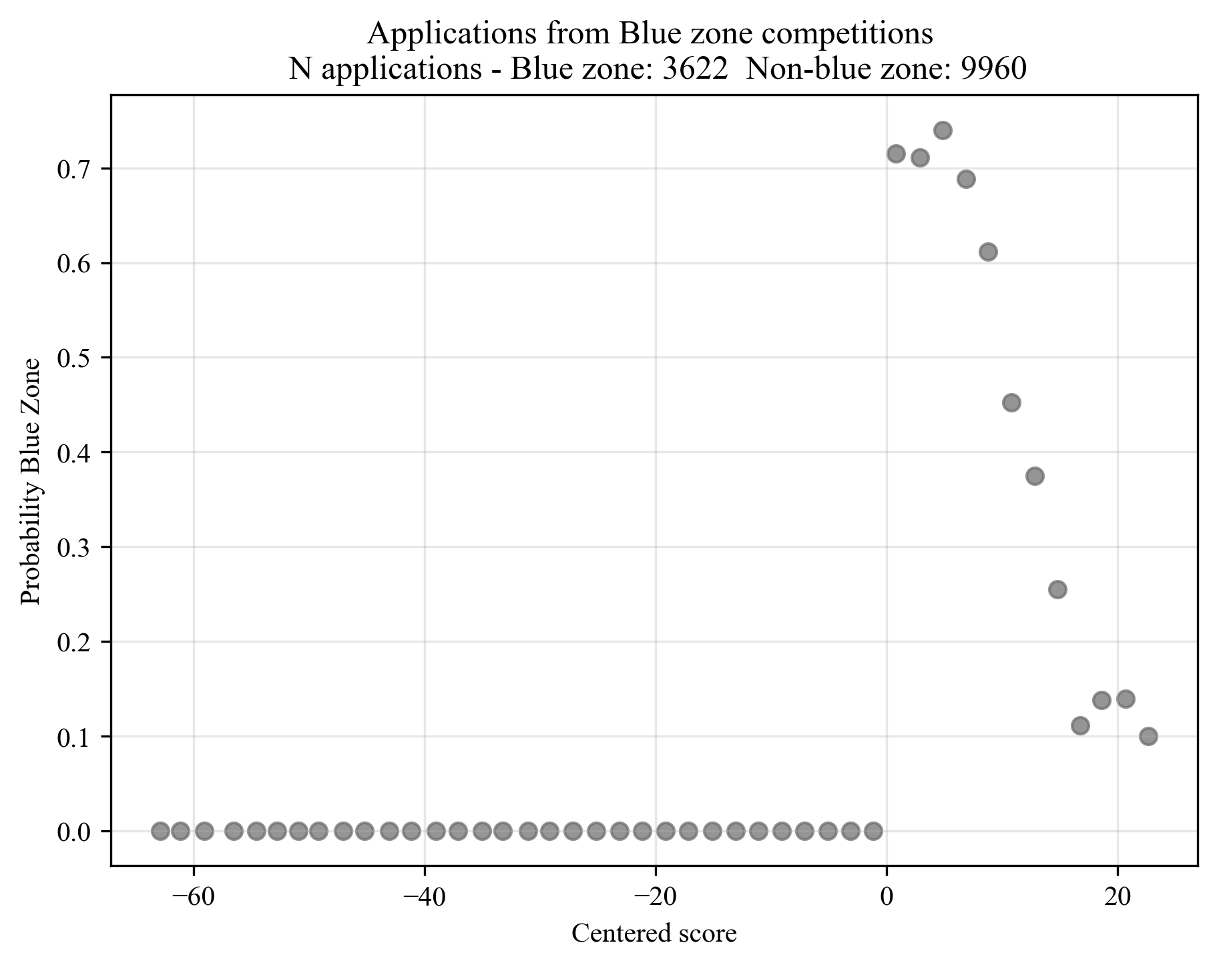
Blue Zones provide a separate policy-relevant setting for analysing post-decision behaviour. Some applications are assessed as fundable but are not funded because of limited budgets. These applications may receive a Blue Zone designation, and applicants are encouraged to reapply. Figure 10 shows how the Blue Zone threshold is constructed in competitions where this status is observed. Applicants do not know in advance whether a Blue Zone will be used in a given competition, which makes it possible to compare applications just below and just above the Blue Zone line.
Blue zone threshold = first score entering the blue zone
Bandwidth with firms used for RDD

Figure 10: Blue Zone threshold among applications from Blue Zone competitions
Figure 11 reports the estimated effect of being just above the Blue Zone threshold on reapplication. The estimates do not show statistically distinguishable effects at any observed horizon. This suggests that telling marginal firms that their application was fundable but not funded, and encouraging them to reapply, may not by itself materially increase reapplication rates. This also suggests that the ‘certification effect’ of being deemed fundable by IUK does not generate an additional benefit in terms of promoting future funding applications by that applicant.

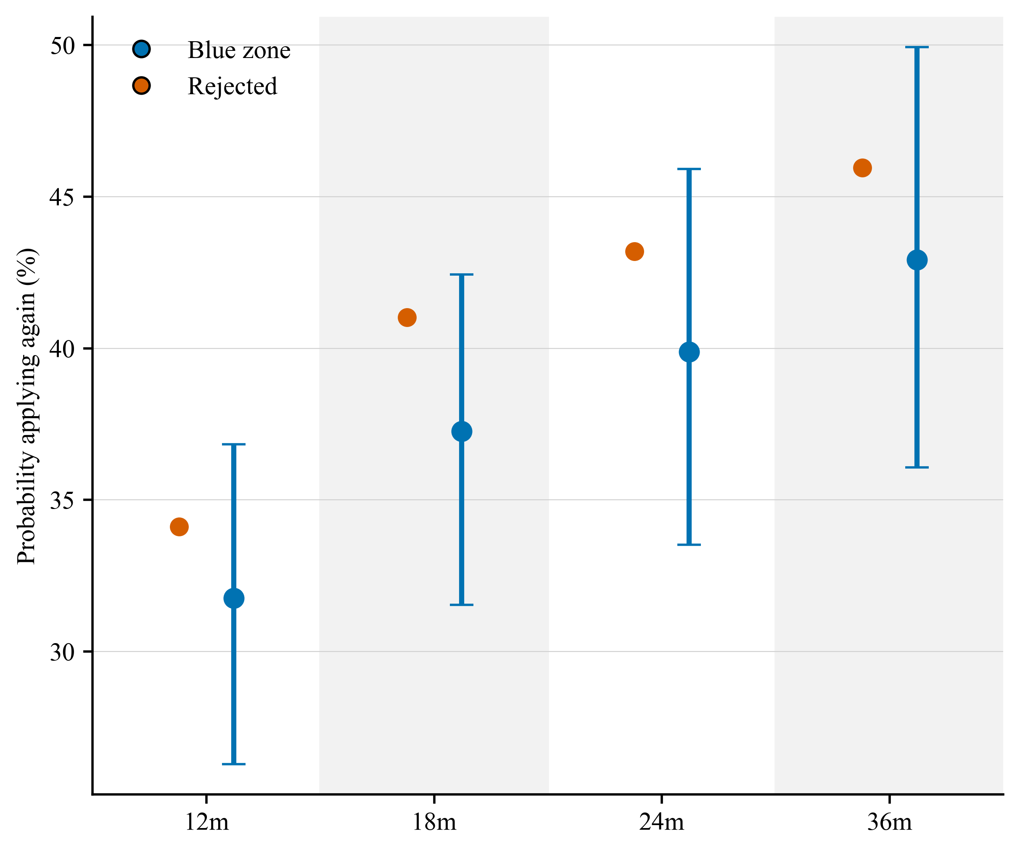
Figure 11: Effect of being just above the Blue Zone threshold on reapplication

Summary of Part II
Part II does not support a simple discouragement story. Firms that narrowly miss funding do not leave the IUK system in the short run. Instead, they are more likely to reapply quickly, and they also have a higher probability of winning subsequent funding over the same period. Among startups, the pattern changes over time: rejected startups return more quickly, while funded startups are more likely to re-enter the funding system over longer horizons. Blue Zone designation does not have a statistically distinguishable effect on reapplication. These findings suggest that post-decision behaviour is shaped by timing and firm type, rather than by a simple divide between encouragement and discouragement.
The post-decision behaviour therefore shapes who remains in the IUK funding system. Part III looks at what changes for firms that win funding.

Part III: Effects of Innovate UK funding

Why funding effects matter
The third part of the report examines whether receiving IUK funding changes subsequent firm outcomes. The analysis focuses first on private finance because one important policy question is whether public innovation funding crowds in or crowds out private investment (Howell, 2017; Lerner, 2000). This is particularly relevant for startups, where access to venture funding can shape growth trajectories, survival and the ability to commercialise innovation, and these firms operate under significant financial constraints.
There is a long-standing debate on whether public R&D support complements or substitutes for private investment. Some studies suggest that early public awards can increase subsequent venture capital by certifying firm quality, reducing technological uncertainty, or helping firms reach key development milestones (Howell, 2017; Lerner, 2000). Other work raises concerns about potential crowding-out, selection problems, or inefficiencies in public support programmes (Lerner, 2009; Wallsten, 2000). The effect of public funding is therefore an open question, especially in settings where grants are allocated through competitive processes.
Prior work on IUK has examined the business performance of funded firms using matched-sample approaches (Dimos & Vorley, 2023; Vanino et al., 2019; Wilson et al., 2026). This evidence is important because it compares funded firms with similar non-funded firms. However, matching approaches mainly address balance on observed characteristics and do not fully remove concerns about unobserved differences between funded and non-funded firms. The RDD approach, used here, provides a complementary approach by comparing applicants close to the funding threshold.
The analysis also looks beyond private venture financing. While venture funding is a central outcome for startups, public innovation grants may affect other dimensions of firm activity, including survival, publications, open-source activity and hiring. Existing causal evidence on these broader outcomes is more limited. Howell (2017), for example, provides positive evidence on venture funding and patenting in the US context of an energy technology focused programme, but there is less evidence on whether public grants affect other forms of scientific, technical or operational activity (Santoleri et al., 2024).
The same fuzzy RDD logic is used as in Part II. The comparison is between marginally funded firms and similar firms just below the funding threshold. The estimates should therefore be interpreted as local effects for applications close to the cutoff, rather than as average effects for all IUK-funded firms.

Effects on venture funding
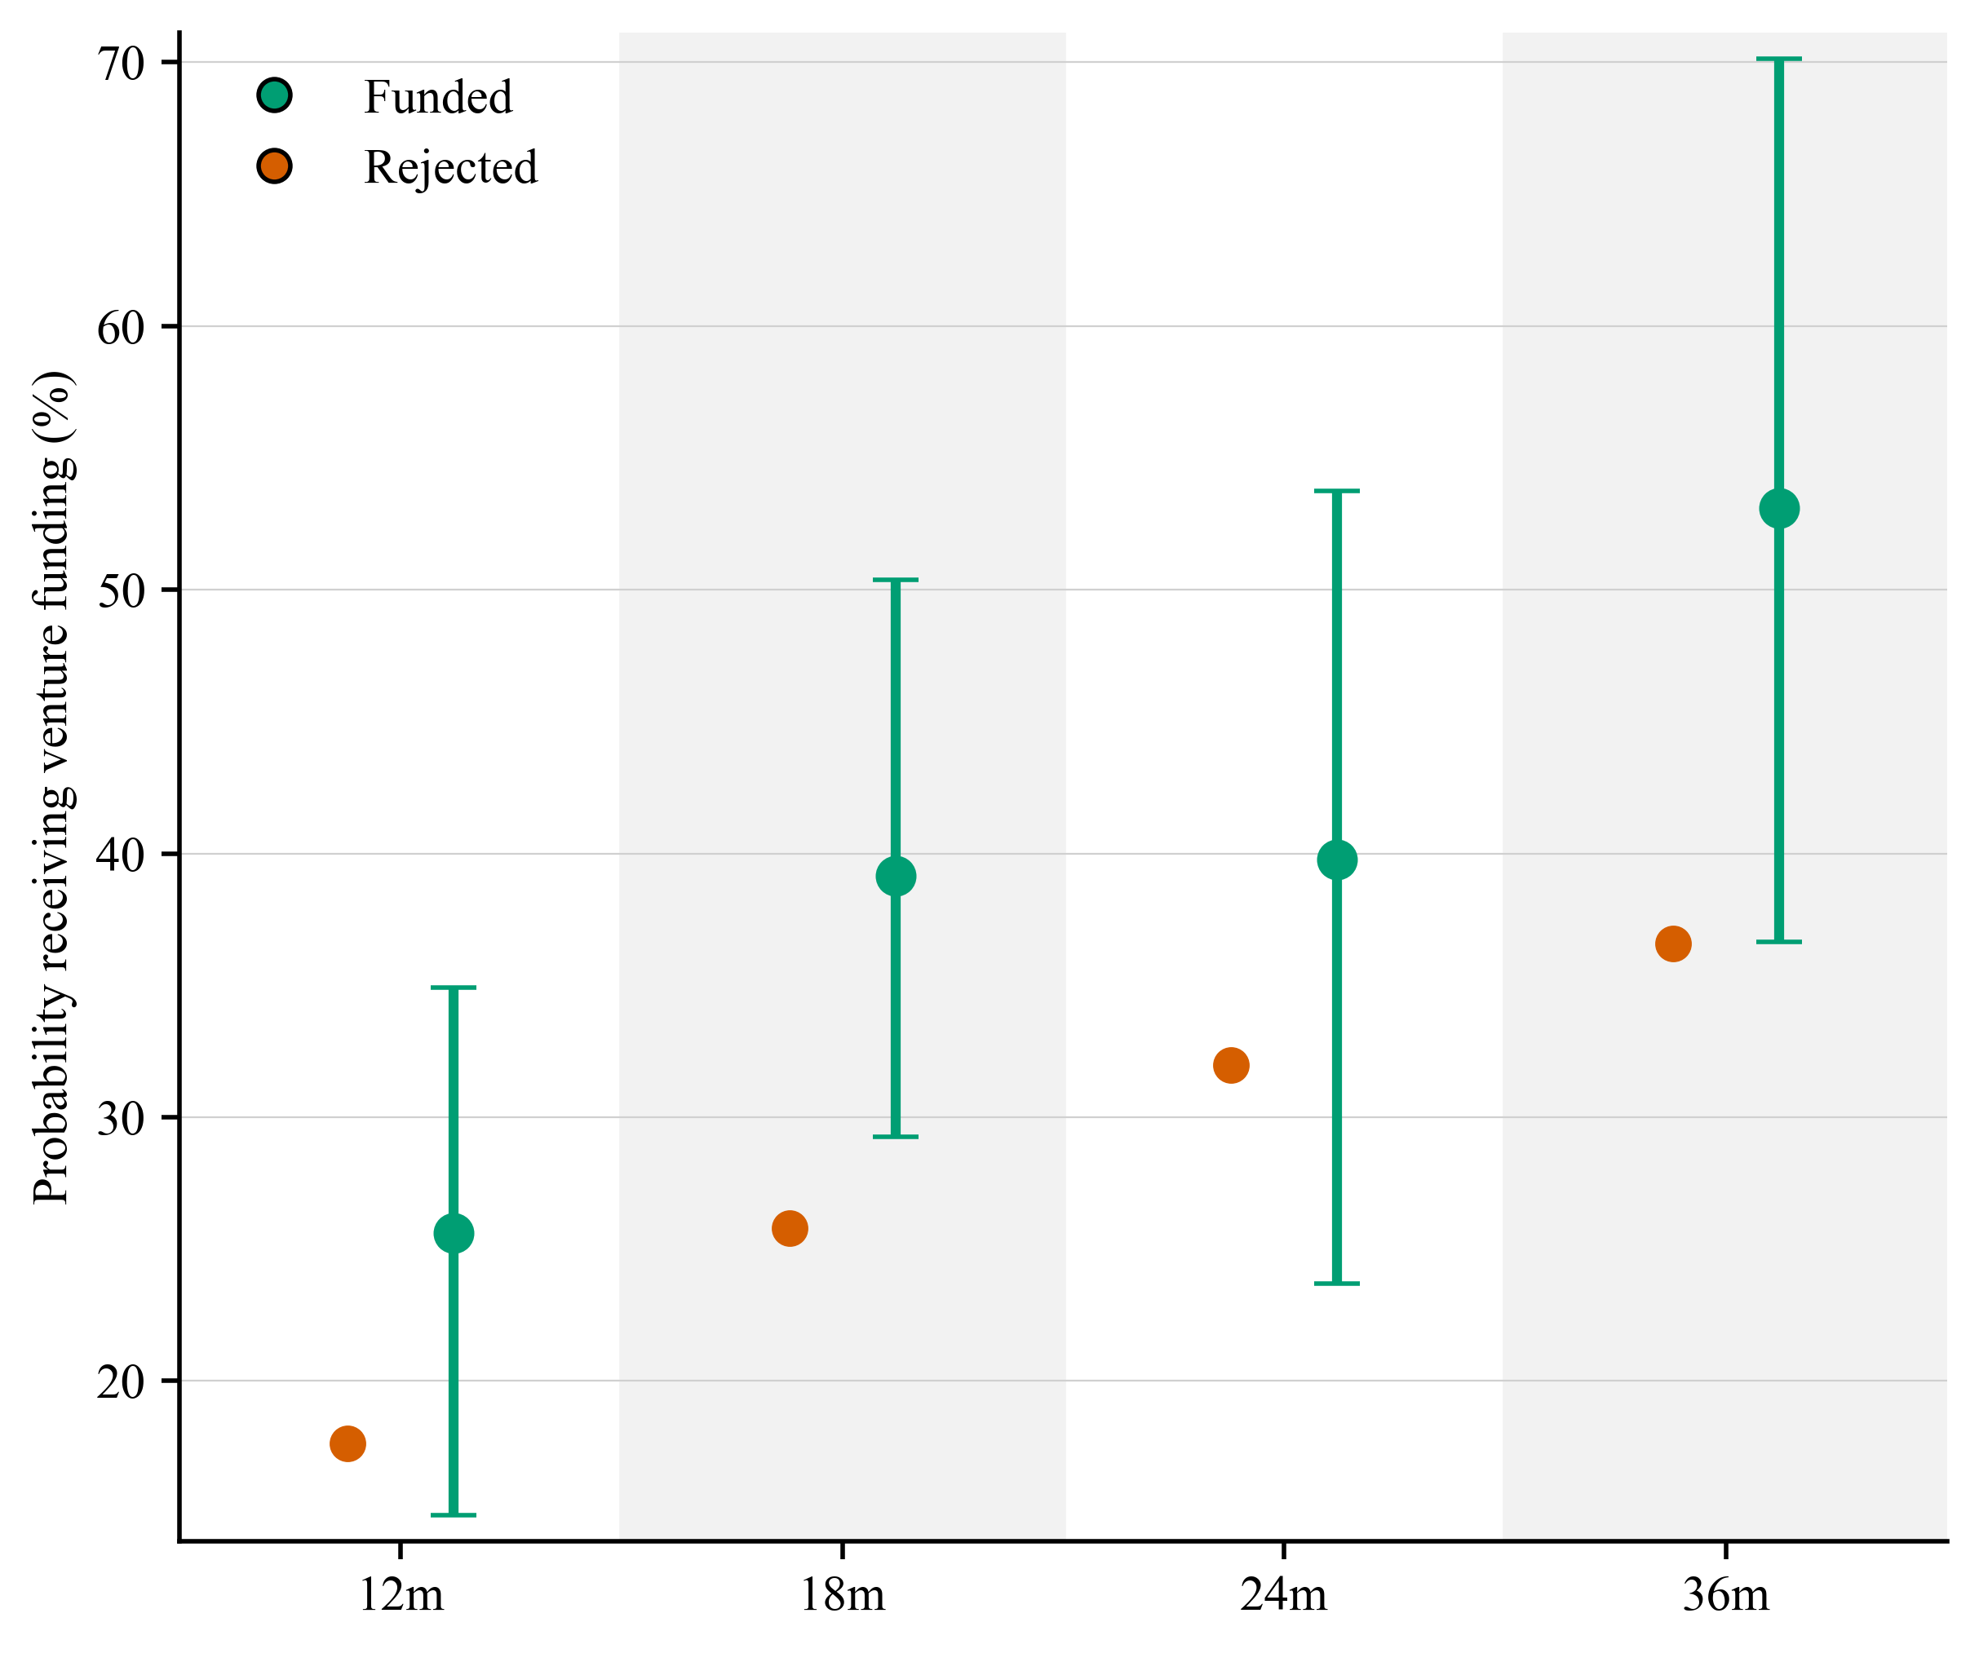
Figure 12 presents the estimated probability of receiving venture funding after the IUK funding decision. The outcome includes private investment, such as venture capital and angel investment, and provides the clearest evidence on whether public R&D funding is followed by additional private finance.

Figure 12: Probability of receiving venture funding within 12, 18, 24 and 36 months, startup sample
The evidence in Figure 12 is telling. Funded firms are more likely to receive subsequent venture funding than comparable firms just below the threshold. At 18 months, rejected firms have a 25.8% probability of receiving venture funding compared with 39.2% for funded firms. At 36 months, the corresponding figures are 36.6% and 55.7%, although the 36-month estimate is marginally significant.
This pattern is consistent with a ‘crowding-in’ interpretation. IUK funding may help firms attract private finance by reducing uncertainty, validating the project, accelerating technical progress, or increasing investor attention. The analysis cannot distinguish between these mechanisms, but the evidence points clearly to a positive effect on subsequent private finance.
The implied magnitude is economically meaningful. Using the 18-month extensive-margin estimate, the analysis suggests that £1 of IUK funding is associated with approximately £1.68 in additional venture funding, with a 90% confidence interval from £0.44 to £3.08. This calculation combines the estimated increase in the probability of receiving private investment, the average private investment size and the average grant size among funded firms. It should therefore be read as an approximate scaling calculation, not as a guaranteed return to every pound of public funding.

Amount of venture funding
The extensive-margin result is complemented by analysis of the amount of funding raised. Investment amounts are highly skewed, so Figure 13 uses a log transformation of the amount raised plus one. This specification reduces the influence of very large funding rounds while preserving the comparison between marginally funded and marginally unfunded firms.
The results point in the same direction as the extensive-margin estimates. At 18 months, the log funding value is 3.3 for rejected firms and 5.1 for funded firms, a difference of approximately 1.8. This implies that funded firms raise substantially more venture funding than comparable rejected firms. This difference corresponds approximately to funded firms raising around 5.9 times more venture funding than rejected firms.
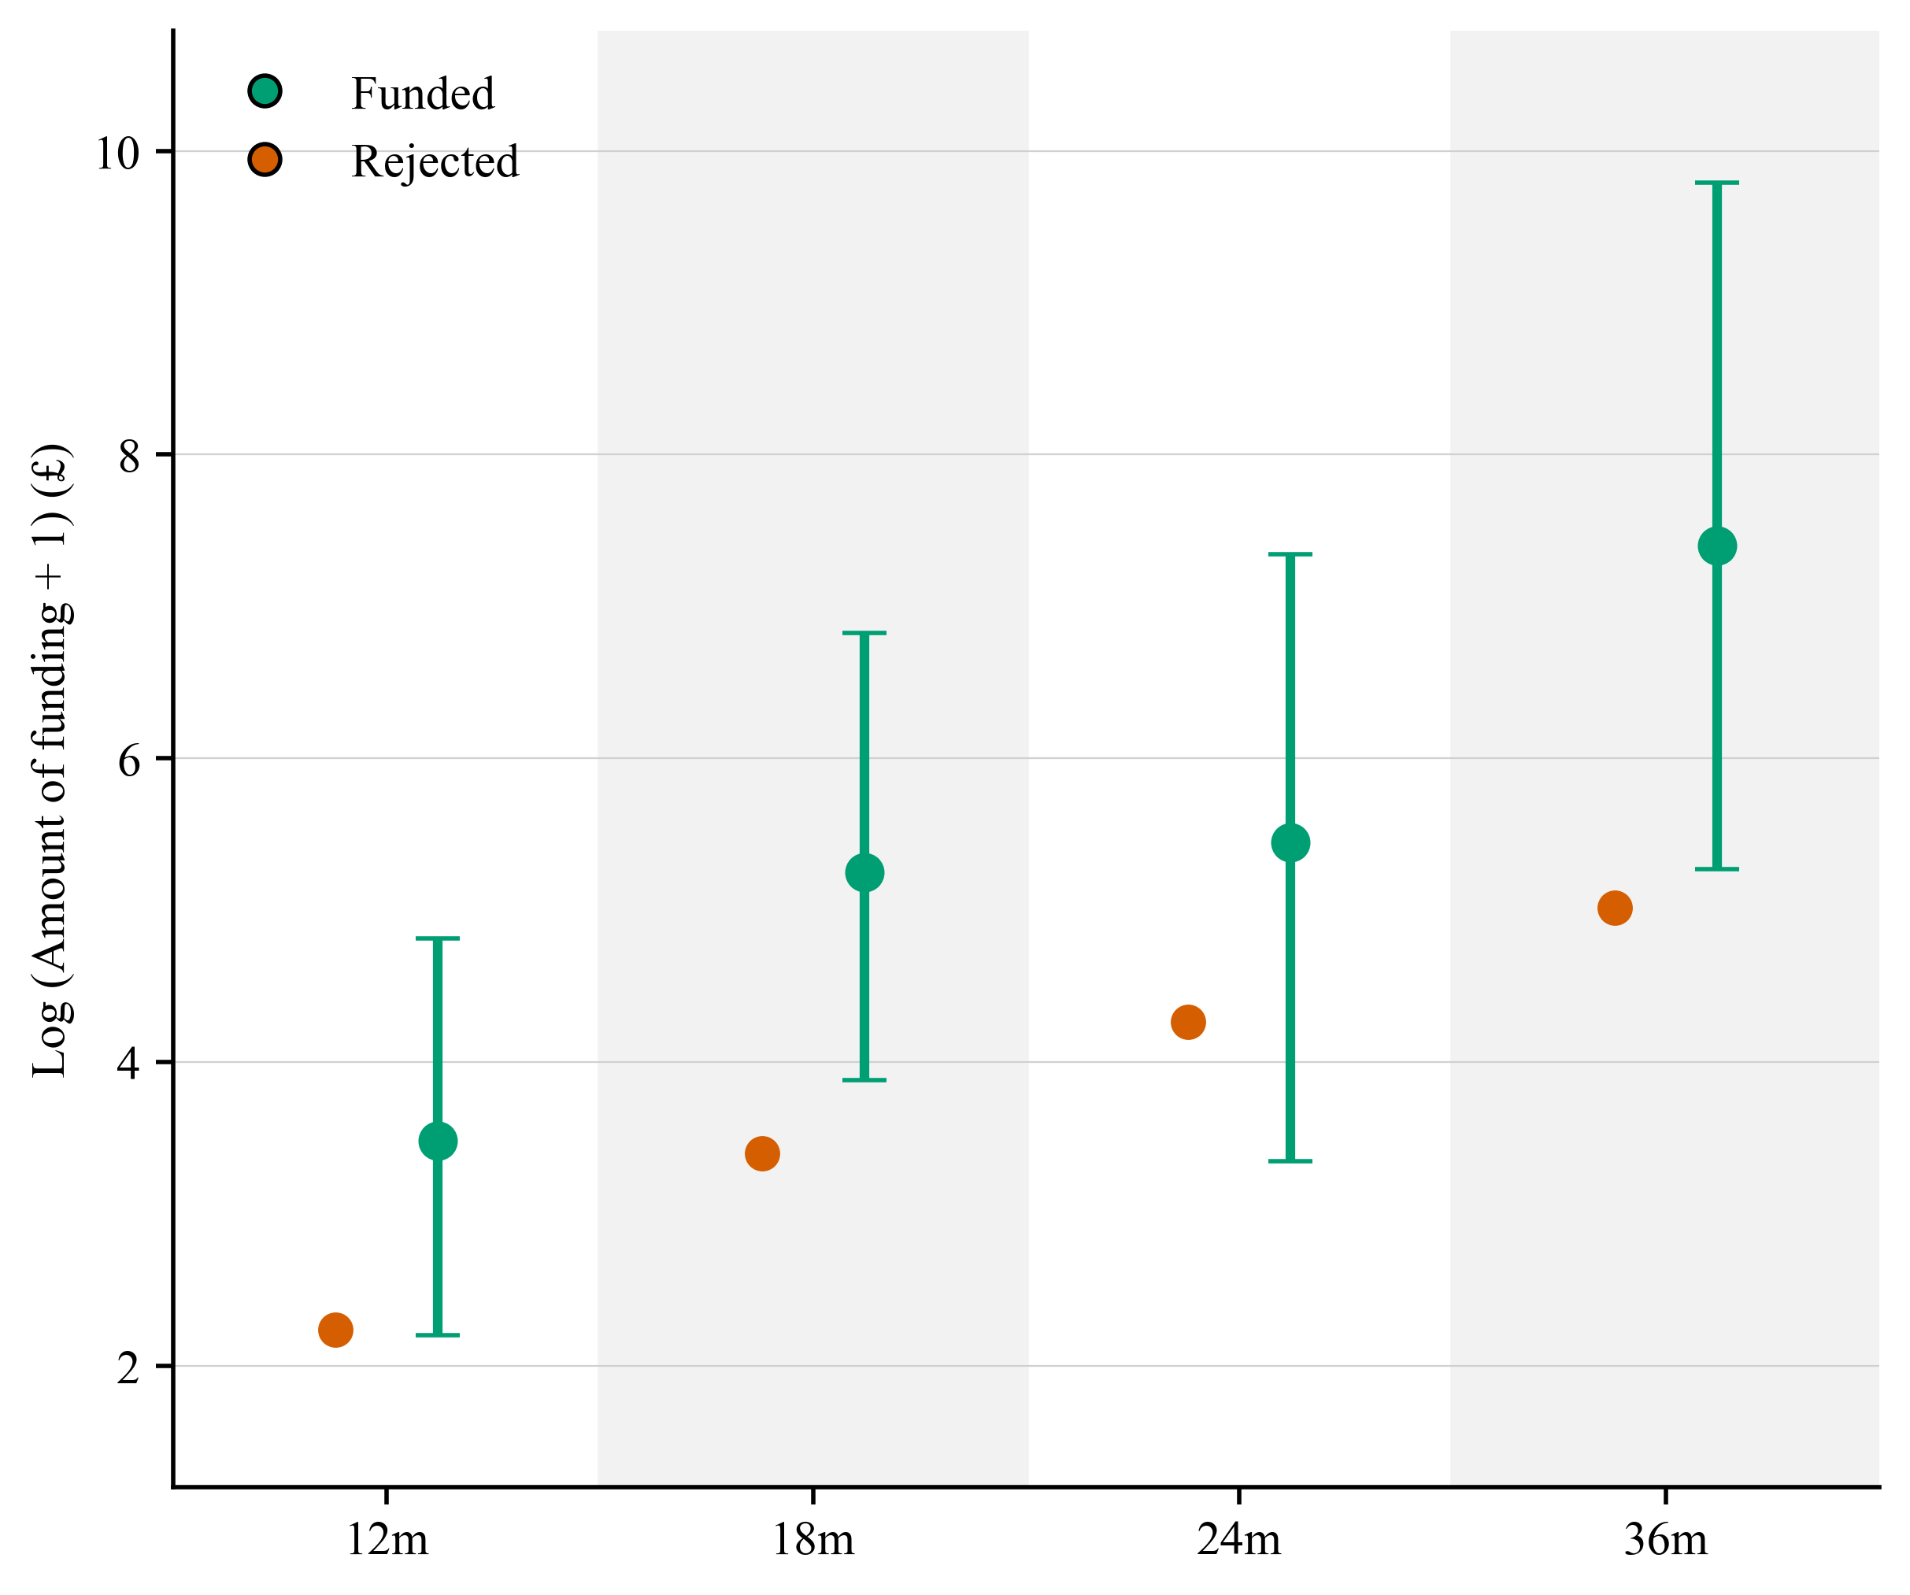
This is a large effect, but it is consistent with prior causal evidence on R&D grants using RDDs and log funding outcomes. Howell (2017), for example, estimates a difference of around 1.40 in log venture capital, equivalent to roughly four times more venture funding. Santoleri et al. (2024) report effects on private equity investment in the range of approximately 0.7 to 1.4 log points, corresponding to around 1.5 to 4 times more investment. The magnitude reported here is therefore at the upper end of existing estimates, but not outside the range of effects found in related studies.

Figure 13: Log amount of venture funding raised within 12, 18, 24 and 36 months, startup sample

AI firms
The point estimate is especially large for AI startups. After 18 months, funded AI startups have an estimated 86.7% probability of receiving venture funding, compared with 36.3% for comparable rejected AI firms. This points to a large positive effect of IUK funding on subsequent private finance among marginal AI applicants.
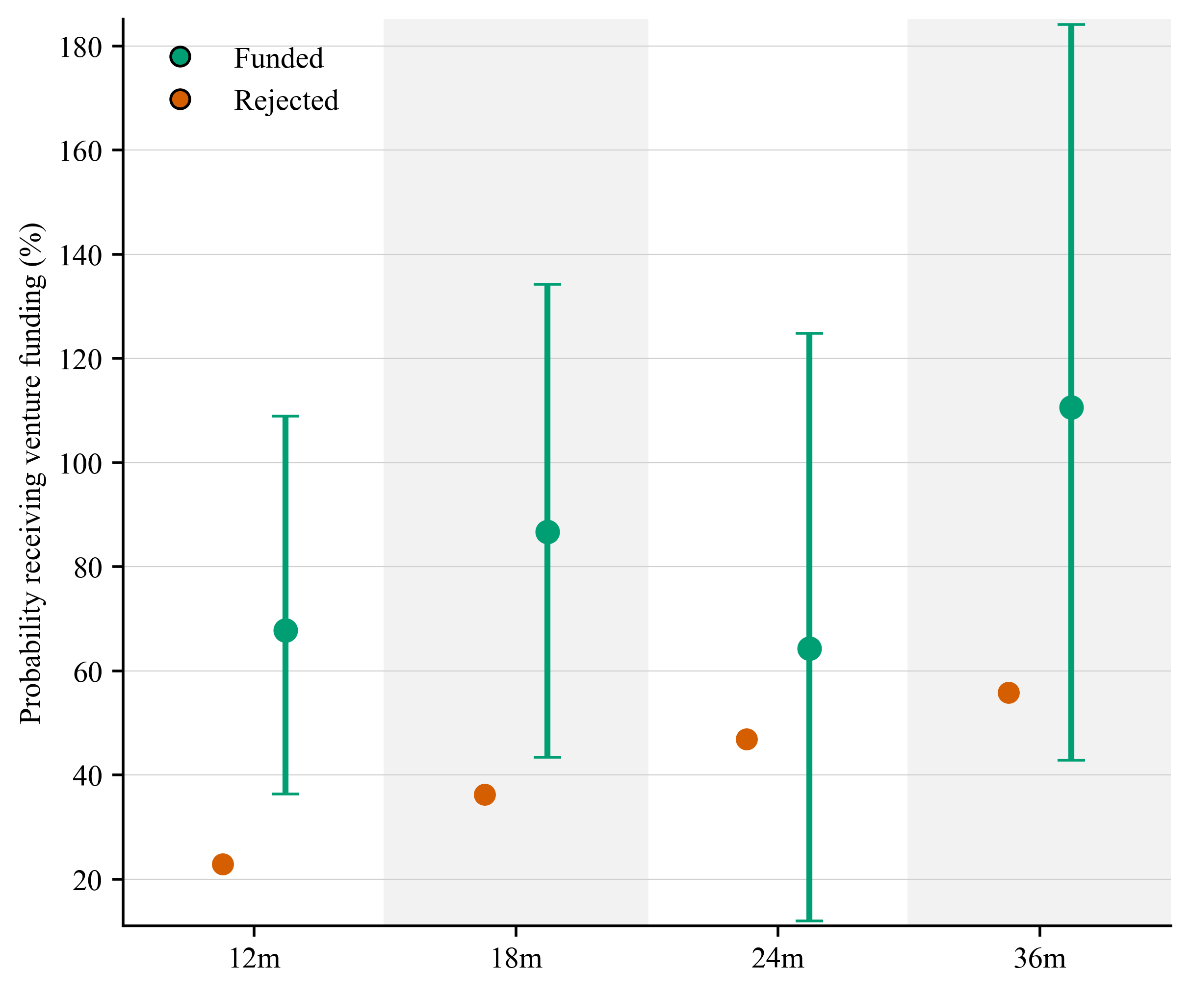
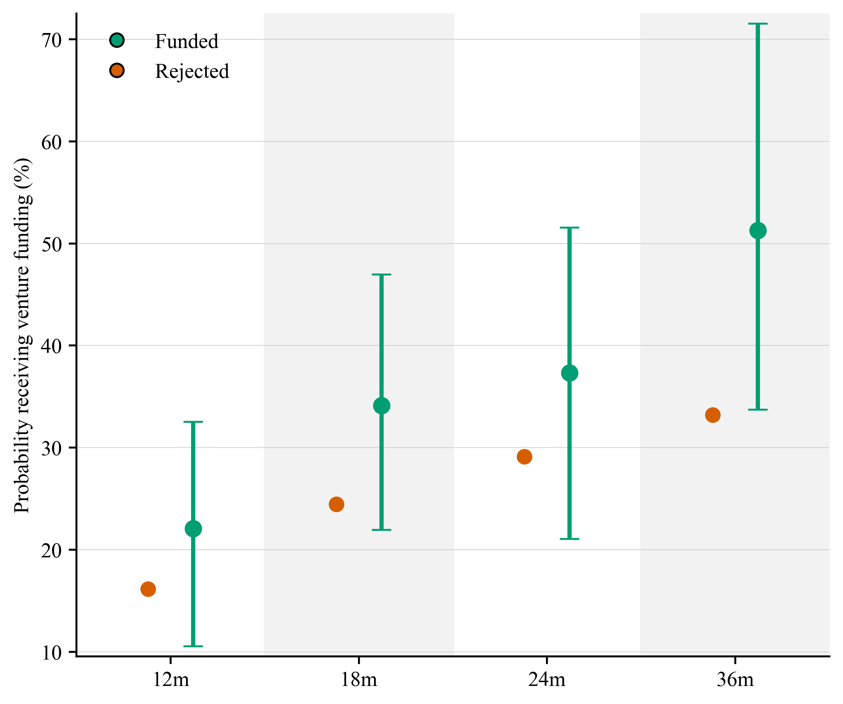
However, the AI-specific estimates are imprecise, with wide confidence intervals reflecting the smaller number of AI firms close to the funding threshold. The result should therefore be read as evidence of a large point estimate for AI firms, rather than as definitive evidence that the effect is statistically different from the effect for non-AI firms.
AI
Non-AI

Figure 14: Probability of receiving venture funding, AI firms (left) and non-AI firms (right)

Publications
In the full sample, IUK funding appears to increase publication output at longer horizons. The count estimates are positive at 18, 24 and 36 months, suggesting that funded firms publish more than comparable rejected firms after receiving support. However, the log-transformed results are weaker and the binary publication outcomes show little evidence of an effect. The publication result therefore appears to operate mainly on the intensive margin: IUK funded firms that publish produce more publications, but funding does not clearly increase the probability that firms begin publishing.
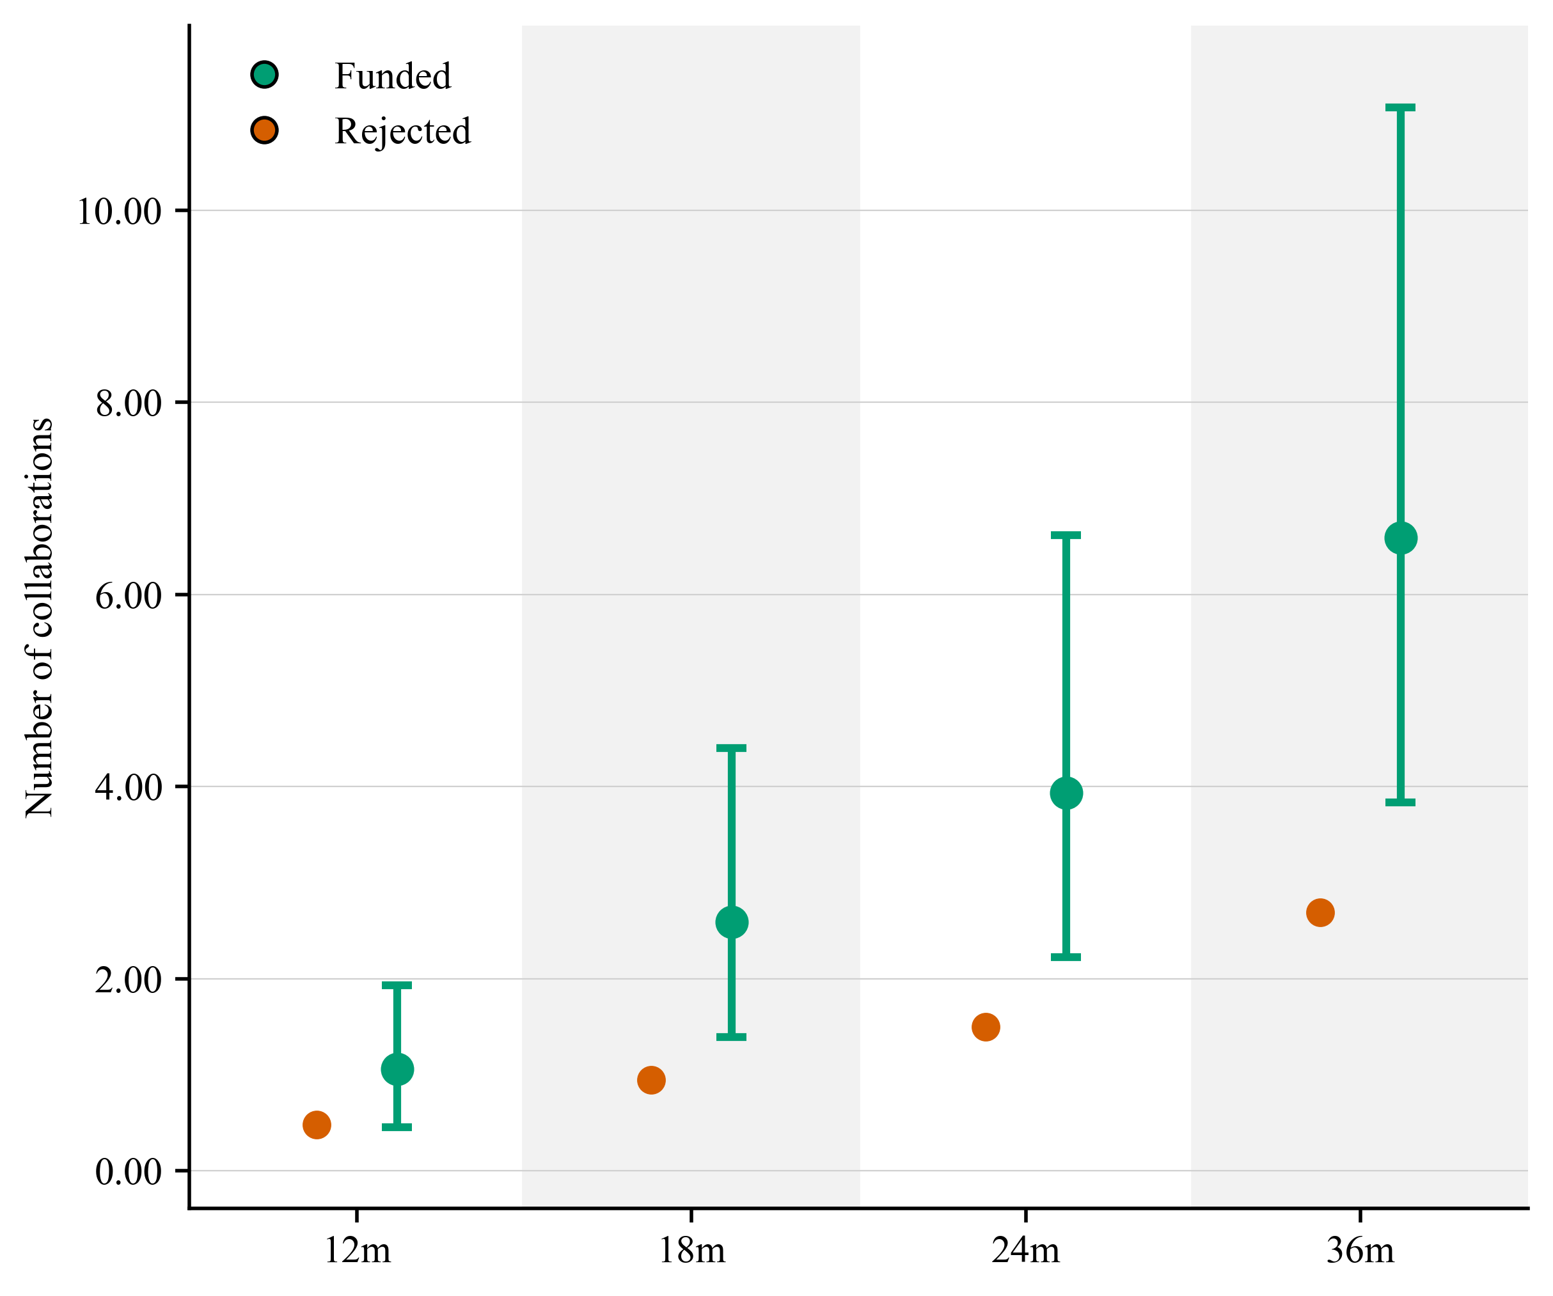
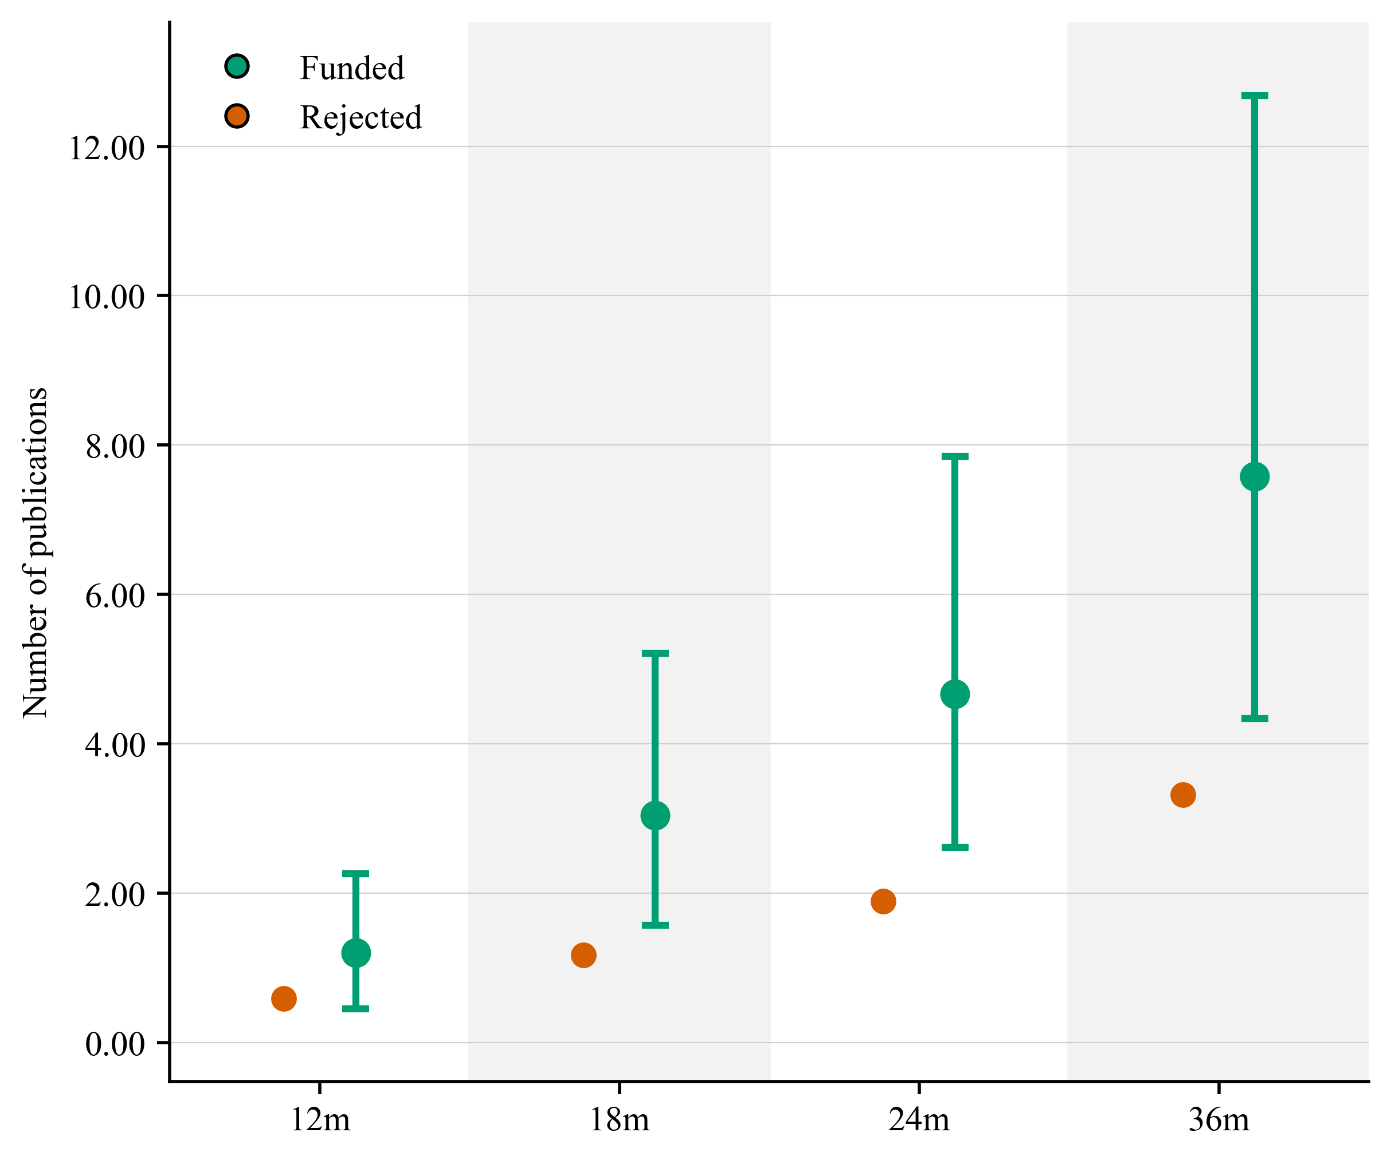
The results for collaboration, measured by co-authored scientific publications with universities, are stronger. In the full sample, IUK-funded firms have higher collaboration counts at 18, 24 and 36 months, and these effects also appear in the log-transformed models. The binary collaboration results are weaker, with only limited evidence that funding increases the probability of collaborating at all. This again points to an intensive-margin effect: IUK funding appears to increase the amount of collaborative scientific activity among firms already engaged in such activity, rather than substantially expanding the set of firms that collaborate.

Figure 15: Number of publications and collaborations after the Innovate UK application, full sample
The startup results differ from the full-sample results. Among startups, IUK funding does not appear to increase publication or collaboration activity at 12, 18 or 24 months. At 36 months, funded startups show lower publication output than comparable rejected startups, and this negative result appears across count, log-transformed and binary publication measures. Collaboration outcomes show a similar negative pattern at 36 months, although the evidence is weaker. These results suggest that the positive publication and collaboration effects observed in the full sample do not extend to startups.
These findings require some qualification. In the full sample, the positive publication result is sensitive to the inclusion of firms with substantial publication activity before application. When firms with 50 or more pre-submission publications are excluded, the positive estimates become much smaller and less precise. This suggests that the full-sample publication effect is concentrated among firms that were already active scientific publishers before receiving funding. Among startups, by contrast, the negative 36-month publication effect remains after excluding firms with high pre-submission publication counts, suggesting that it is not driven by a small number of already prolific publishers.
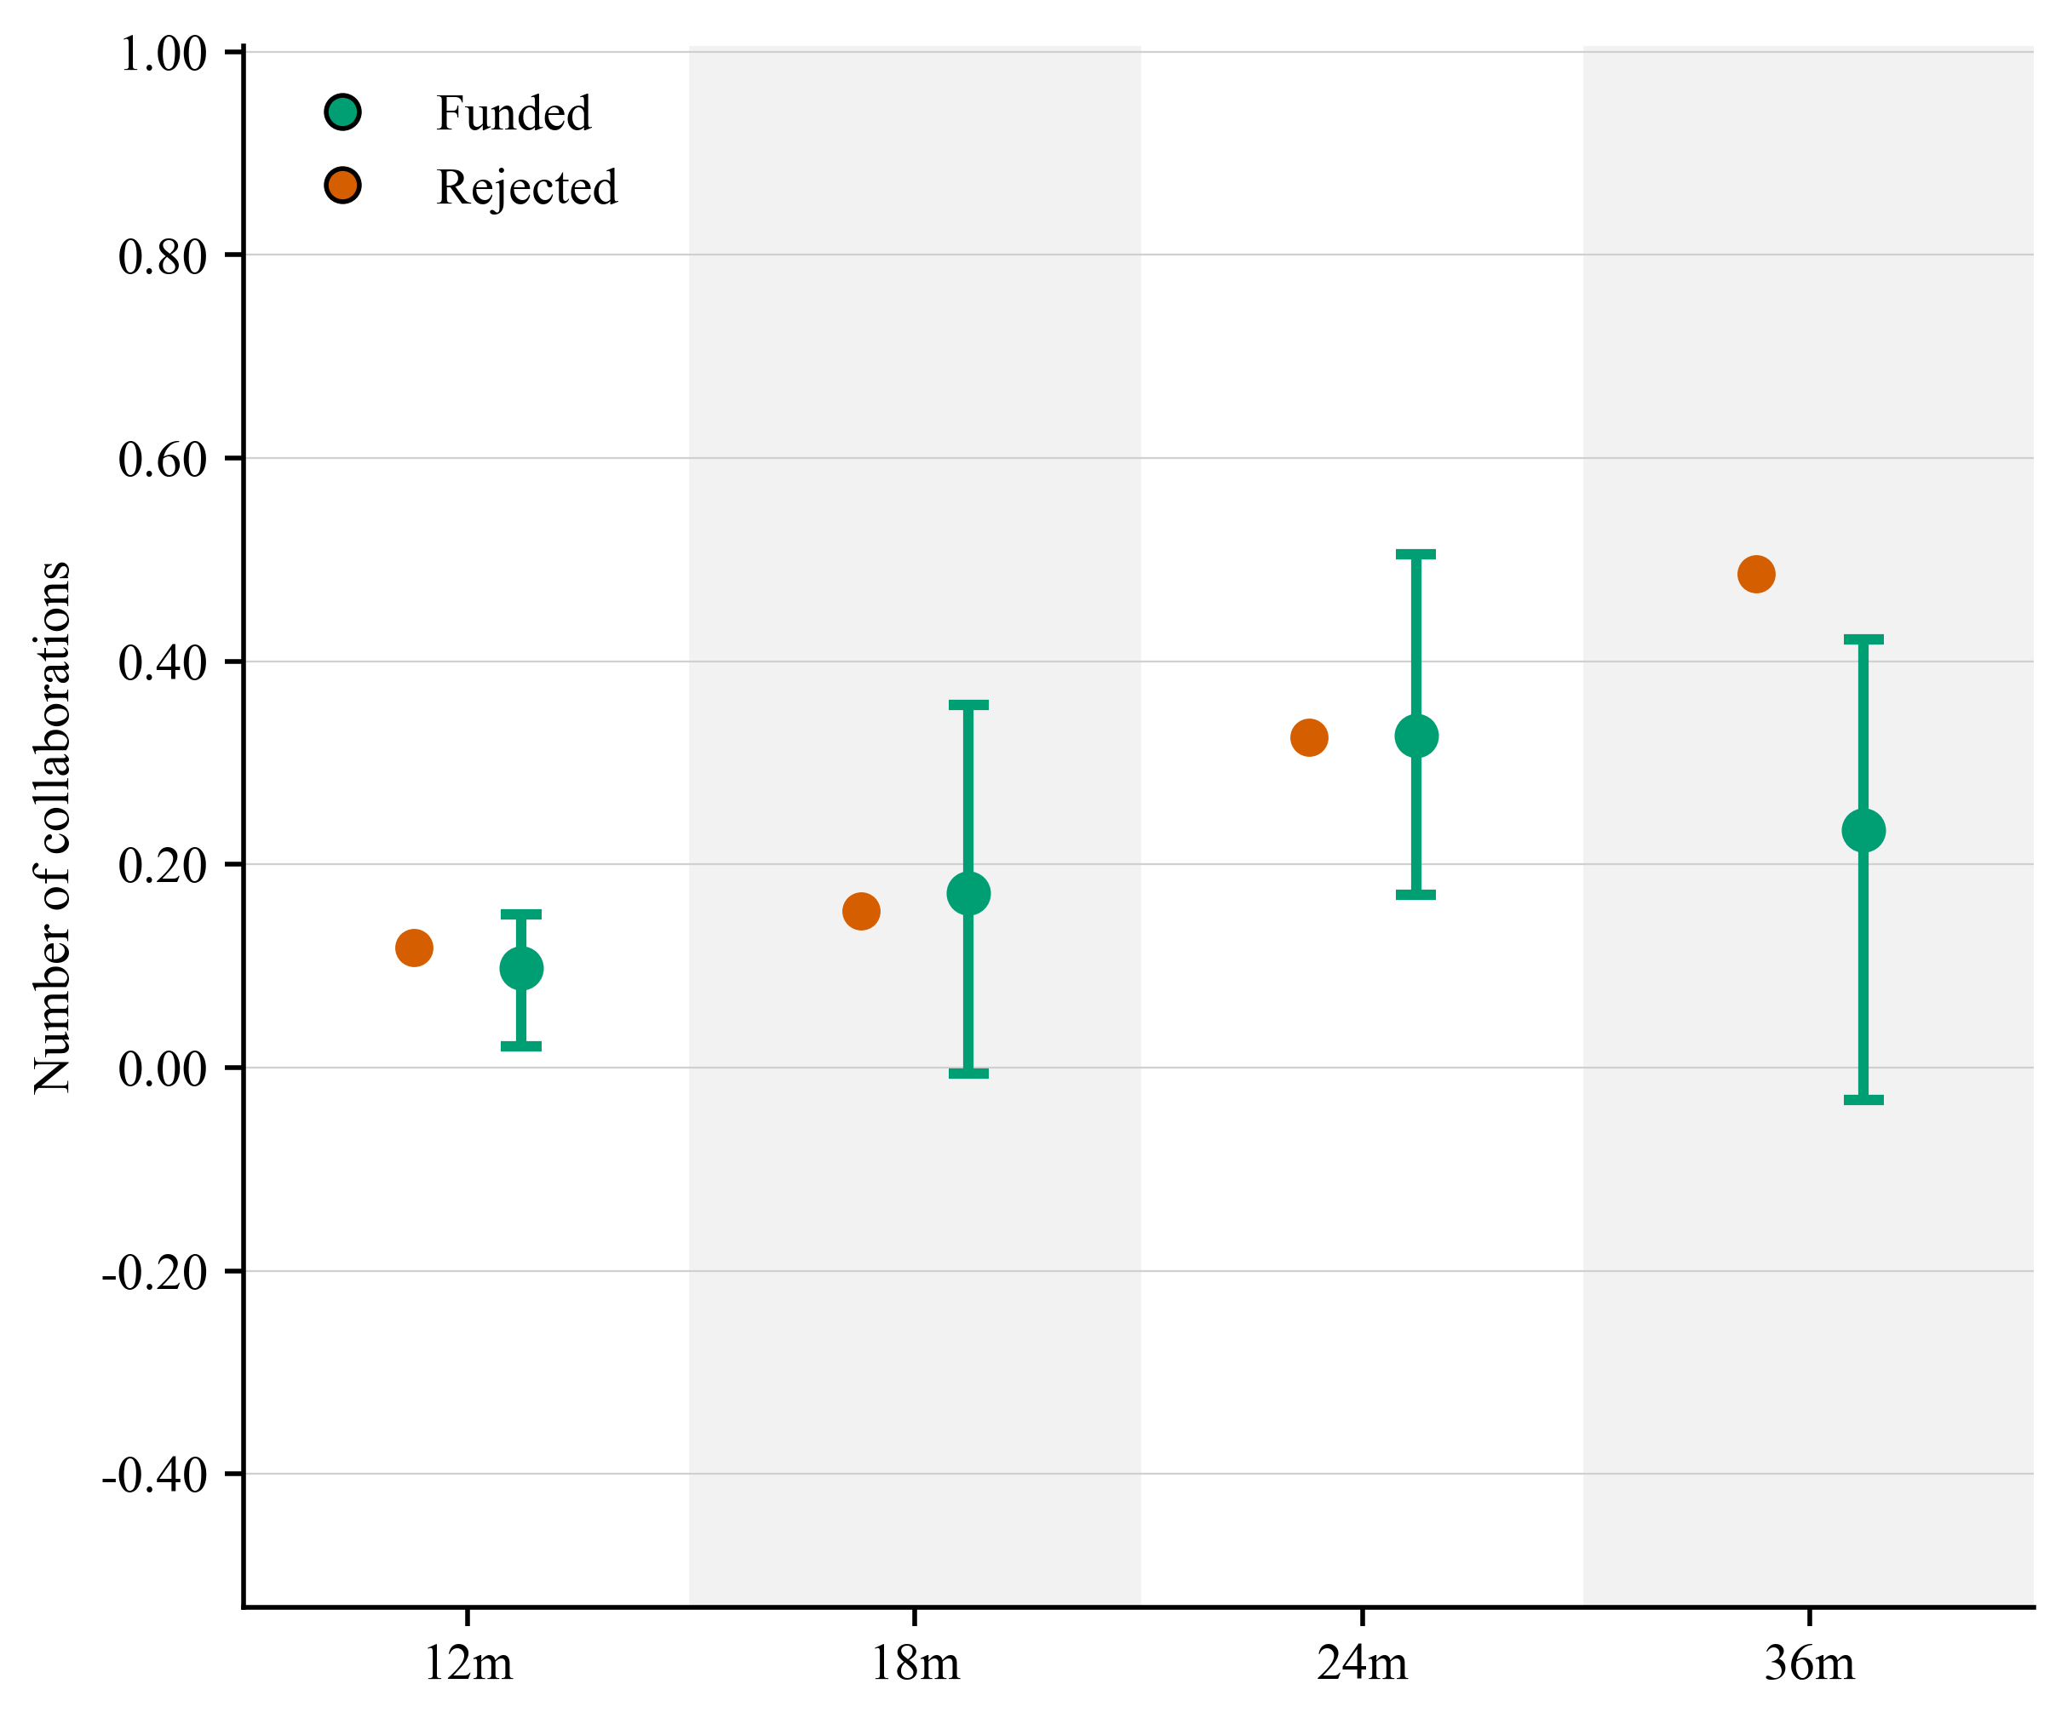
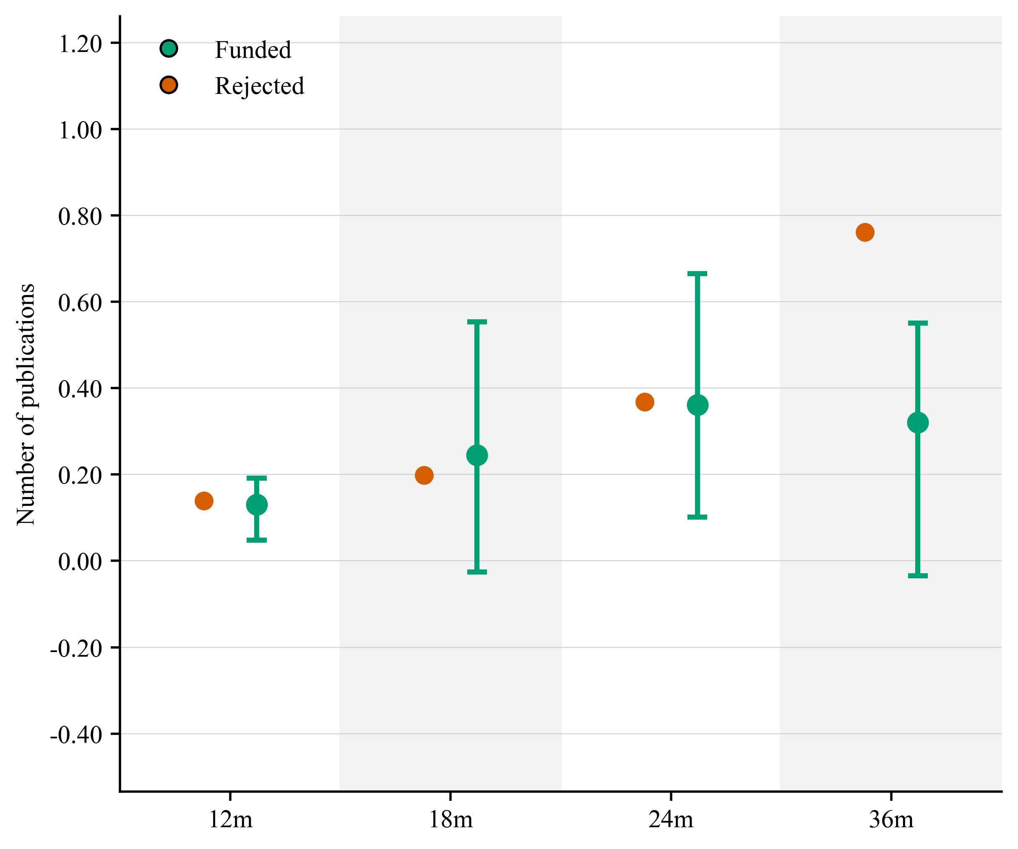

Figure 16: Number of publications and collaborations after the Innovate UK application, startup sample

Hiring
The hiring analysis is based on the subset of firms observed in Revelio Labs. This covers 61% of applicants in the full sample and 58% of startup applicants. The results should therefore be interpreted as evidence on observed hiring among Revelio-covered firms, rather than as evidence for the entire applicant population.
The hiring results provide little evidence that IUK funding increases subsequent hiring. In the full sample, total hires and R&D-role hires show no clear positive effects across horizons. The startup results are also weak. Total hiring shows no clear effect in either the count or log-transformed models. For R&D-role hiring in Figure 17, the count model shows lower hiring among funded firms at 36 months, but the corresponding log estimate is not statistically significant. This suggests that the result may be driven by a small number of rejected firms with high R&D-role hiring, rather than by a broad hiring difference between funded and rejected startups.
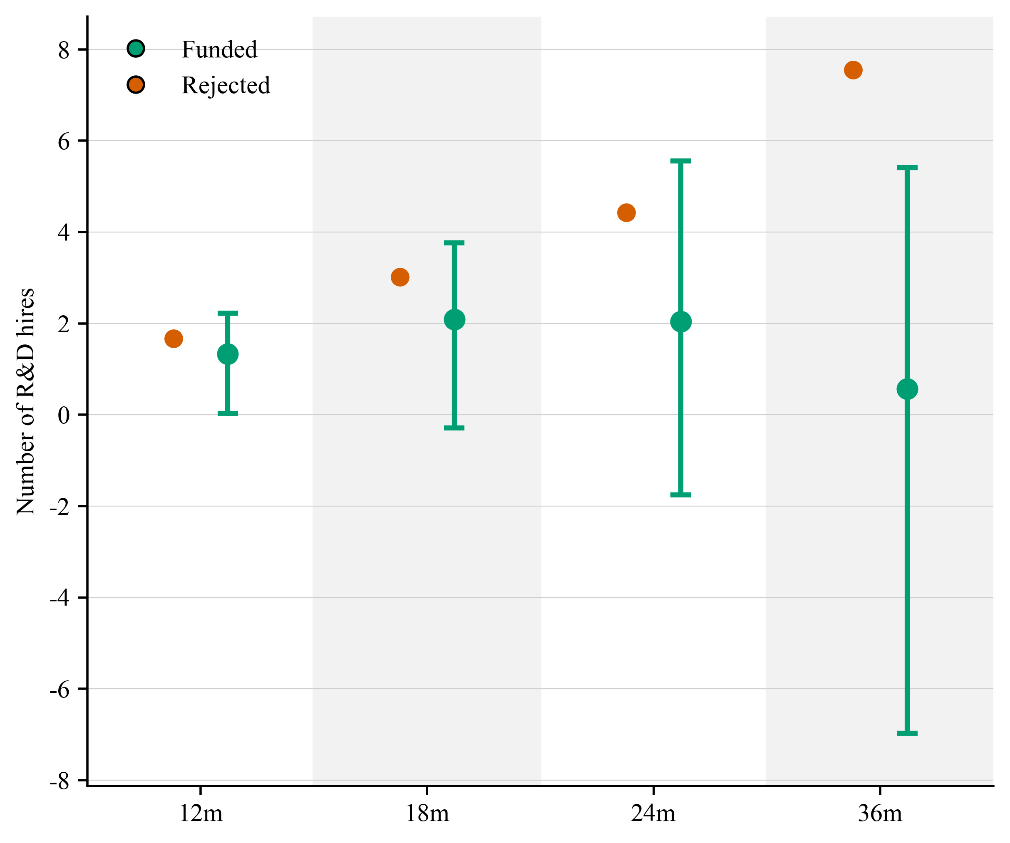
These findings should be interpreted cautiously. The estimates do not provide clear evidence that IUK funding increases observed R&D-role hiring in the short to medium run. There are important limitations to measuring hiring using Revelio data and to the job roles assigned within these data. Further work will be required to obtain more reliable and consistent employment data.

Figure 17: Number of new research and development hires after the Innovate UK application, startup sample

Dissolution and GitHub activity
IUK funding does not have a statistically significant effect on firm dissolution at any observed horizon. This is a reassuring null: there is no sign that marginal funding keeps weaker firms alive artificially relative to comparable rejected firms. In addition, GitHub activity, which is a measure of open-source software contributions (Lin & Maruping, 2022), shows no clear effect on repositories, stars or forks. This outcome is observed for only around 8–9% of firms in the sample, so the absence of an effect should not be over-interpreted.

What the additional evidence suggests
Results for other measures of IUK funding’s impact on startup outcomes are less consistent than the venture finance results. In the full sample, there is some evidence of higher publication and collaboration activity at longer horizons, especially for collaborations. However, these effects appear mainly on the intensive margin, and the publication result is sensitive to the inclusion of firms with substantial publication activity before application.
The startup results do not show the same pattern. Funding does not increase publication or collaboration activity among startups, and the 36-month publication estimates are negative across several specifications. Hiring, dissolution and GitHub activity also show no clear positive effects. Overall, the current analysis does not show a broad increase in observable scientific, technical or operational outcomes after IUK funding. The most persistent and consistent effect remains the ‘crowding-in’ of private venture finance.

Summary of Part III
Part III provides causal evidence that winning IUK funding increases subsequent venture finance among marginal startup applicants. The effect appears both in the probability of receiving venture funding and in the amount of funding raised. The evidence supports a ‘crowding-in’ interpretation: IUK funding appears to help firms attract additional private finance after receiving public support. These effects are economically meaningful and large, suggesting that IUK funding helps to stimulate private sector investment decisions, helping UK startups gain access to critical resources to scale up and expand their operations.
Effects on other outcomes are less clear. In the full sample, there is some evidence of higher publication and collaboration activity at longer horizons, especially for collaborations. However, these effects appear mainly on the intensive margin. The publication result is also concentrated among firms with substantial pre-existing scientific activity. Among startups, the publication and collaboration results do not show a positive effect, and the 36-month publication estimates are negative.
Hiring results are mixed and exploratory, with no clear evidence that funding increases total hiring or R&D staff. There is no statistically significant effect on dissolution and no clear effect on GitHub activity. The most visible effect of Innovate UK funding in the current analysis is through private finance, rather than through immediately observable scientific or operational outcomes.

Discussion and policy implications
We have tried to bring together data from IUK with public sources to try to understand the experience of firms across the innovation funding lifecycle. In doing so, we have been able to extend prior work on the impact of IUK funding on companies, especially startups. Below, we explore some of the implications of this work for IUK, innovation policy evaluation and AI startups.

Finding and engaging potential innovative firms
The results suggest that companies self-select into IUK competitions, and that such choices are determined by these organisations’ assessment of their chances of success and failure. Such perceptions may be influenced by where these companies are located, how they were created, and who funds them. This suggests that differences in engagement in IUK competitions appear to be partly driven by these startups’ stakeholders and their environment as well as their internal choices. As such, IUK needs to increase its efforts to onboard startups, and broaden its engagement to those startups that lack these relationships.
IUK has some information on firms that attend or participate in its outreach efforts, but a more structured and real-time effort to track those firms that could potentially apply would be helpful. Careful analysis of application rates among startups and across different sectors and regions could help to identify potential missing pools of applicants. Moreover, communication and promotion efforts may need to be aligned to the variety of startups that are active in our economic system. With the use of generative AI, it is possible for very small startups to undertake a wide range of activities. As such, greater efforts could be made to reach out to these firms to try to give them the support and help they need to start their progression through their development cycle.
IUK has indicated that it will be moving away from the competition model, including discontinuing SMART competitions. Such an approach will require greater attention to finding those firms that need support and guiding them to appropriate services, rather than relying on the lure of funding from competitions. Our results suggest that firms that lack affiliations with venture funders and universities may be less likely to apply, which suggests that IUK may need to act as a surrogate stakeholder to help direct these firms to potentially useful sources of support.

Responding to rejection and acceptance
IUK rejects many more applicants than it funds. This can lead to considerable ill-will among rejected applicants, who may feel that the selection process is biased or poorly organised. Such feelings are common in selection systems which involve high uncertainty and high levels of rejection. Some IUK competitions have acceptance rates below 10%, which may further feed a sense that the costs of applying are greater than the potential benefits of winning. For many applicants, who expend considerable effort to apply, only to be rejected and given modest feedback, the sting of rejection could lead to outright hostility to the funding agency.
It must be said that IUK needs to avoid making the costs of application too low, as it will be flooded with many low-quality applications. Indeed, in the age of generative AI, it is easy to generate plausible text. Without some care to the incentive structures of application, IUK could be flooded with AI-written applications, leading to a destruction of the evaluation system which is already costly and challenging to coordinate and run. The cost of evaluating an IUK application is roughly £600 (five evaluators each paid £120), which does not include the administrative costs of the process at IUK. Our data only cover the period to the end of 2024 and newer generative AI models are more capable than the early public versions, so it is not easy for us to state whether the costs of applying have shifted downwards, while the costs of assessment have remained stable. In funding systems, there is a delicate balance between ensuring that a selection system rewards high-quality submissions and ensuring that it does not deter novel applications or new entrants. In this environment, the effect of rejections on applications may change, as they can bid again more easily. Our research cannot directly address this issue, but it is suggestive that rejection before and after the arrival of public generative AI tools, after the launch of ChatGPT in November 2022, does not deter reapplication, except among startups.
Companies that apply to IUK and are rejected do not appear to be discouraged from reapplying for funding in the long term. This suggests that rejection and high failure rates in competitions are not having a deterrence effect on most companies. However, our results show that startups that are rejected are likely to feel the ‘sting of failure’ for many years afterwards. This indicates that IUK needs to find ways to engage rejected startups to consider reapplication after failure, so they are not deterred from trying again. Extra support and attention should be given to raise awareness of the potential for reapplication and build these companies’ ability to bounce back.

Grants attract capital, not additional research activity
We find causal evidence that IUK funding stimulates additional external venture financing, as startups receiving a grant are more likely to obtain funding and to raise larger amounts than those rejected. These effects mirror the results of other reports for other R&D grants programmes and R&D tax credits. Indeed, the effects are economically meaningful, suggesting that IUK funding plays a key role in leveraging additional private funding. For every one pound of IUK funding, startups receive an additional £1.68 of private venture funding. The level of venture funding also increases, as IUK funded firms, on average, receive 5.9 times more venture funding than unfunded ones. Since our analysis compares firms at the margins of funding decisions, and these firms are similar in almost all respects before the funding decision, it is compelling evidence that IUK funding plays an important catalytic role in supporting UK-based startups, helping them win funding and scale up.
However, we find little evidence that IUK funding increases publications, open source software contributions, hiring in R&D, or even firm survival among startups. This suggests that the funding may help with obtaining additional resources for exploitation rather than exploration. Further work will be required to understand other more downstream, near market effects of IUK funding.

Limitations and future research
Several limitations should be kept in mind when interpreting these results. First, the selection into application evidence is descriptive and correlational. Second, the RDD estimates are local to applications close to the funding threshold and should not be generalised to all applicants or all funded firms. Third, the evidence also reflects a specific period and programme mix: some competitions examined here, including SMART grants, no longer exist in the same form. As the programme portfolio evolves, the composition of applicants and the nature of funded projects will change, and the results may not translate directly to current or future programmes. Fourth, our data have some notable gaps and limitations, especially with respect to hiring.
Future work could extend this analysis in several directions. Access to application text and assessor feedback would allow researchers to examine whether the content of the assessment — not just the outcome — shapes reapplication behaviour and firm trajectories. Firms that receive detailed, constructive feedback may respond differently from those that receive only a score. Better data on the timing of firms' engagement with IUK promotion and communication channels would allow a more credible test of whether outreach causes application or whether already-interested firms are simply more likely to subscribe. IUK could run field experiments on its communication efforts to determine whether some forms of external engagement are more successful than others in encouraging applications from underserved groups. We also focused on the experiences of the firms leading these applications, but a significant share of applications involves multiple organisations. Future research could look at the effects of these funding decisions on these collaborators too. Finally, the investor-level data available in this project could be used to examine what kinds of investors the crowding-in effect attracts — whether the IUK signal draws in new investors who would not otherwise have engaged with the firm, or whether it primarily accelerates follow-on investment from existing backers, and whether the response differs across investor types such as venture capital, angel investors and corporate investors.

REFERENCES
Bol, T., De Vaan, M., & Van De Rijt, A. (2018). The Matthew effect in science funding. Proceedings of the National Academy of Sciences, 115(19), 4887–4890. https://doi.org/10.1073/pnas.1719557115
Calonico, S., Cattaneo, M. D., Farrell, M. H., Palomba, F., & Titiunik, R. (2025). Treatment Effect Heterogeneity in Regression Discontinuity Designs (arXiv:2503.13696). arXiv. https://doi.org/10.48550/arXiv.2503.13696
Cattaneo, M. D., & Titiunik, R. (2022). Regression Discontinuity Designs. Annual Review of Economics, 14, 821–851. https://doi.org/10.1146/annurev-economics-051520-021409
Dimos, D. C., & Vorley, T. (2023). Innovate UK grants and R&D returns: Impact on business and economy. Innovation Research Caucus and Oxford Brookes University.
Howell, S. T. (2017). Financing Innovation: Evidence from R&D Grants. American Economic Review, 107(4), 1136–1164. https://doi.org/10.1257/aer.20150808
Ipsos MORI. (2021). Impact review of Innovate UK’s AI-related activity [Interim report]. Ipsos MORI.
Lerner, J. (2000). The Government as Venture Capitalist: The Long-Run Impact of the SBIR Program. The Journal of Private Equity, 3(2), 55–78.
Lerner, J. (2009). Boulevard of Broken Dreams: Why Public Efforts to Boost Entrepreneurship and Venture Capital Have Failed--and What to Do About It. Princeton University Press. https://www.jstor.org/stable/j.ctt7t2br
Lin, Y.-K., & Maruping, L. M. (2022). Open Source Collaboration in Digital Entrepreneurship. Organization Science, 33(1), 212–230. https://doi.org/10.1287/orsc.2021.1538
Mina, A., Di Minin, A., Martelli, I., Testa, G., & Santoleri, P. (2021). Public funding of innovation: Exploring applications and allocations of the European SME Instrument. Research Policy, 50(1), 104131. https://doi.org/10.1016/j.respol.2020.104131
Mulligan, K., George, A., Doran, J., & Bonner, K. (2026). Beyond the Golden Triangle. Innovation Research Caucus. https://ircaucus.ac.uk/publications/beyond-the-golden-triangle/
Perspective Economics. (2023). Artificial Intelligence Sector Study. Department for Science, Innovation & Technology (DSIT).
Santoleri, P., Mina, A., Di Minin, A., & Martelli, I. (2024). The Causal Effects of R&D Grants: Evidence from a Regression Discontinuity. Review of Economics and Statistics, 106(6), 1495–1510. https://doi.org/10.1162/rest_a_01233
Vanino, E., Roper, S., & Becker, B. (2019). Knowledge to money: Assessing the business performance effects of publicly-funded R&D grants. Research Policy, 48(7), 1714–1737. https://doi.org/10.1016/j.respol.2019.04.001
Wallsten, S. J. (2000). The Effects of Government-Industry R&D Programs on Private R&D: The Case of the Small Business Innovation Research Program. The RAND Journal of Economics, 31(1), 82. https://doi.org/10.2307/2601030
Wang, Y., Jones, B. F., & Wang, D. (2019). Early-career setback and future career impact. Nature Communications, 10(1), 4331. https://doi.org/10.1038/s41467-019-12189-3
Wilson, N., Kacer, M., & Cowling, M. (2026). The contribution of Innovate UK to UK firm performance: The Effects of Innovate UK Funding on Firm-Level Total Factor Productivity A follow-up report on IUK applicants for funding (IRC Report No. 069). Oxford, UK: Innovation and Research Caucus.





Innovate UK Business Connect, accessed 2 July 2026, https://iuk-business-connect.org.uk/
The scaling calculation is based on the 18-month extensive-margin estimate within the bandwidth. It multiplies the estimated increase in the probability of receiving private investment by the average private investment size, and divides by the average grant size among funded firms: (0.134 × £3,448,926) / £275,059 = £1.68. This calculation should be interpreted as an approximate average scaling exercise, not as a guaranteed return to each pound of public funding.

